https://cobbler.tcsbank.ru/cobbler_web/

#
# 20190424
# Here is a list of OS’es available to install at this time.
# Cobbler show them in blue menu after server booted with PXE (if for server not specified special personal config depends from its MAC and other things).
#
# Distros
https://10.219.39.1/cobbler_web/distro/list
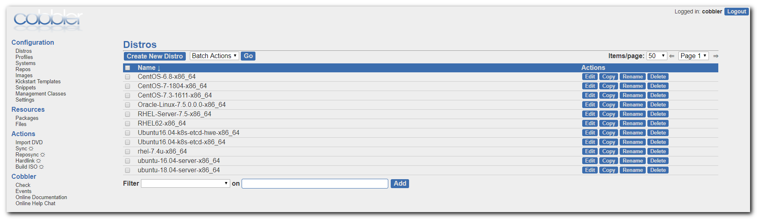

#
# Here is a place, where to see config for installation appropriate distributive.
#
# Profiles
https://10.219.39.1/cobbler_web/profile/list
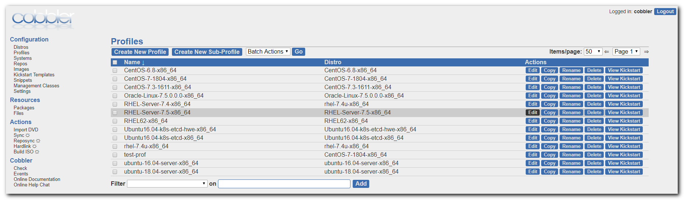

# Was presed Edit button.
# Here is a name of kickstart file, that will be used to OS install.
https://10.219.39.1/cobbler_web/profile/edit/RHEL-Server-7.5-x86_64
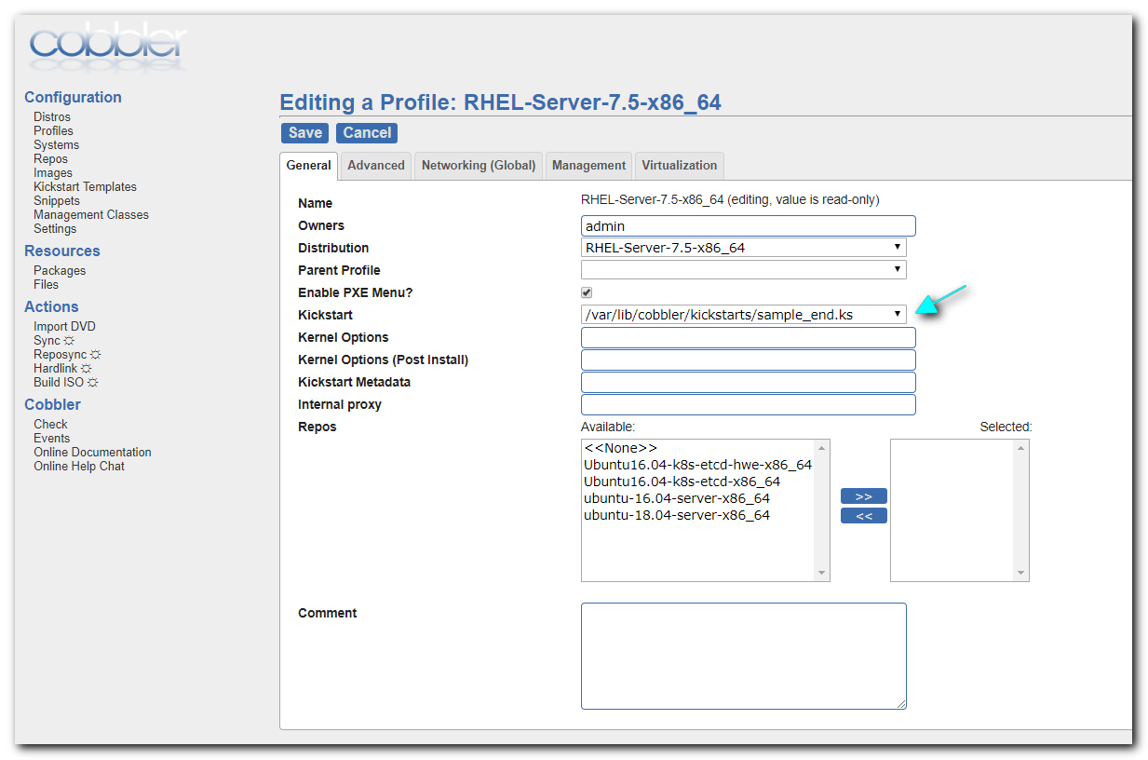
#
# Here we can see template for kickstart. In this template is using cobbler’s variables.
#
# Kickstart Templates
https://10.219.39.1/cobbler_web/ksfile/list
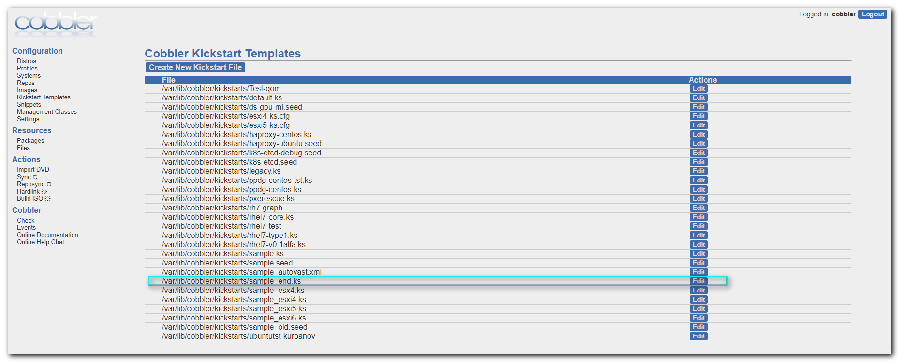

https://10.219.39.1/cobbler_web/ksfile/edit/file:/var/lib/cobbler/kickstarts/sample_end.ks
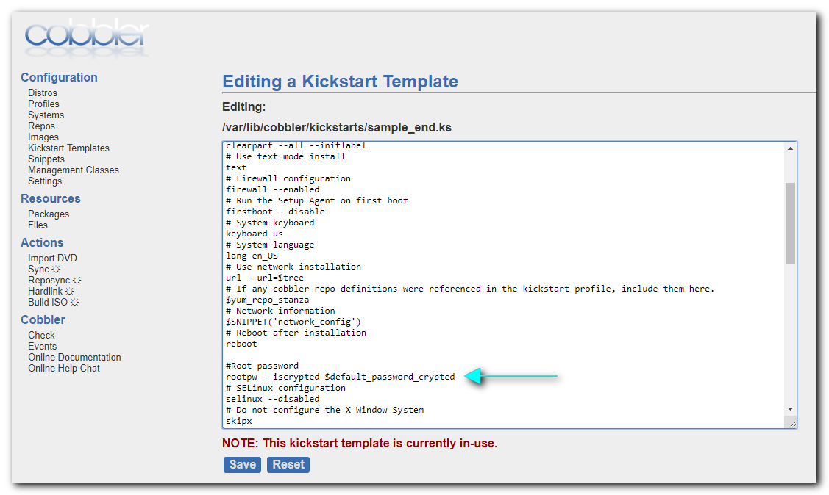

# This kickstart file should only be used with EL > 5 and/or Fedora > 7.
# For older versions please use the sample.ks kickstart file.

#platform=x86, AMD64, or Intel EM64T
# System authorization information
auth --useshadow --enablemd5
# System bootloader configuration
bootloader --location=mbr
# Partition clearing information
clearpart --all --initlabel
# Use text mode install
text
# Firewall configuration
firewall --enabled
# Run the Setup Agent on first boot
firstboot --disable
# System keyboard
keyboard us
# System language
lang en_US
# Use network installation
url --url=$tree
# If any cobbler repo definitions were referenced in the kickstart profile, include them here.
$yum_repo_stanza
# Network information
$SNIPPET('network_config')
# Reboot after installation
reboot

#Root password
rootpw --iscrypted $default_password_crypted
# SELinux configuration
selinux --disabled
# Do not configure the X Window System
skipx
# System timezone
timezone America/New_York
# Install OS instead of upgrade
install
# Clear the Master Boot Record
zerombr
# Allow anaconda to partition the system as needed
autopart

%pre
$SNIPPET('log_ks_pre')
$SNIPPET('kickstart_start')
$SNIPPET('pre_install_network_config')
# Enable installation monitoring
$SNIPPET('pre_anamon')
%end

%packages
$SNIPPET('func_install_if_enabled')
%end

%post --nochroot
$SNIPPET('log_ks_post_nochroot')
%end

%post
$SNIPPET('log_ks_post')
# Start yum configuration
$yum_config_stanza
# End yum configuration
$SNIPPET('post_install_kernel_options')
$SNIPPET('post_install_network_config')
$SNIPPET('func_register_if_enabled')
$SNIPPET('download_config_files')
$SNIPPET('koan_environment')
$SNIPPET('redhat_register')
$SNIPPET('cobbler_register')
# Enable post-install boot notification
$SNIPPET('post_anamon')
# Start final steps
$SNIPPET('kickstart_done')
# End final steps
%end

#
# Here we can see what exactly kickstart file will be used for server install.
https://10.219.39.1/cobbler_web/profile/list
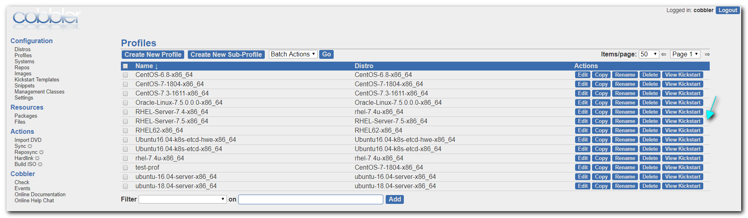

#
# This is kickstart for rhel 7.5.
# Password for root user is 123456
#
https://10.219.39.1/cblr/svc/op/ks/profile/RHEL-Server-7.5-x86_64
# This kickstart file should only be used with EL > 5 and/or Fedora > 7.
# For older versions please use the sample.ks kickstart file.

#platform=x86, AMD64, or Intel EM64T
# System authorization information
auth --useshadow --enablemd5
# System bootloader configuration
bootloader --location=mbr
# Partition clearing information
clearpart --all --initlabel
# Use text mode install
text
# Firewall configuration
firewall --enabled
# Run the Setup Agent on first boot
firstboot --disable
# System keyboard
keyboard us
# System language
lang en_US
# Use network installation
url --url=http://10.219.39.1/cblr/links/RHEL-Server-7.5-x86_64
# If any cobbler repo definitions were referenced in the kickstart profile, include them here.
repo --name=source-1 --baseurl=http://10.219.39.1/cobbler/ks_mirror/RHEL-Server-7.5-x86_64
repo --name=source-2 --baseurl=http://10.219.39.1/cobbler/ks_mirror/RHEL-Server-7.5-x86_64/addons/ResilientStorage
repo --name=source-3 --baseurl=http://10.219.39.1/cobbler/ks_mirror/RHEL-Server-7.5-x86_64/addons/HighAvailability

# Network information
network --bootproto=dhcp --device=eth0 --onboot=on

# Reboot after installation
reboot

#Root password
rootpw --iscrypted $6$gxOzrJsD$5eaMnOb1/xx0zcrhjZhIoLgXLs1UMyZJYJIqedHoAFH6gORDZD3lQtBk/QedpU46/5to3XxFgDxINx5unwkn4/
# SELinux configuration
selinux --disabled
# Do not configure the X Window System
skipx
# System timezone
timezone America/New_York
# Install OS instead of upgrade
install
# Clear the Master Boot Record
zerombr
# Allow anaconda to partition the system as needed
autopart

%pre
set -x -v
exec 1>/tmp/ks-pre.log 2>&1

# Once root's homedir is there, copy over the log.
while : ; do
sleep 10
if [ -d /mnt/sysimage/root ]; then
cp /tmp/ks-pre.log /mnt/sysimage/root/
logger "Copied %pre section log to system"
break
fi
done &

curl "http://10.219.39.1/cblr/svc/op/trig/mode/pre/profile/RHEL-Server-7.5-x86_64" -o /dev/null

# Enable installation monitoring

%end

%packages

%end

%post --nochroot
set -x -v
exec 1>/mnt/sysimage/root/ks-post-nochroot.log 2>&1

%end

%post
set -x -v
exec 1>/root/ks-post.log 2>&1

# Start yum configuration
curl "http://10.219.39.1/cblr/svc/op/yum/profile/RHEL-Server-7.5-x86_64" --output /etc/yum.repos.d/cobbler-config.repo

# End yum configuration

# Start post_install_network_config generated code
# End post_install_network_config generated code

# Start download cobbler managed config files (if applicable)
# End download cobbler managed config files (if applicable)

# Start koan environment setup
echo "export COBBLER_SERVER=10.219.39.1" > /etc/profile.d/cobbler.sh
echo "setenv COBBLER_SERVER 10.219.39.1" > /etc/profile.d/cobbler.csh
# End koan environment setup

# begin Red Hat management server registration
# not configured to register to any Red Hat management server (ok)
# end Red Hat management server registration

# Begin cobbler registration
# cobbler registration is disabled in /etc/cobbler/settings
# End cobbler registration

# Enable post-install boot notification

# Start final steps

curl "http://10.219.39.1/cblr/svc/op/ks/profile/RHEL-Server-7.5-x86_64" -o /root/cobbler.ks
curl "http://10.219.39.1/cblr/svc/op/trig/mode/post/profile/RHEL-Server-7.5-x86_64" -o /dev/null
# End final steps
%end

# Here is a place, where to set up default password for root user, that will use cobbler in its kickstart files.
#
# Settings
https://10.219.39.1/cobbler_web/setting/list
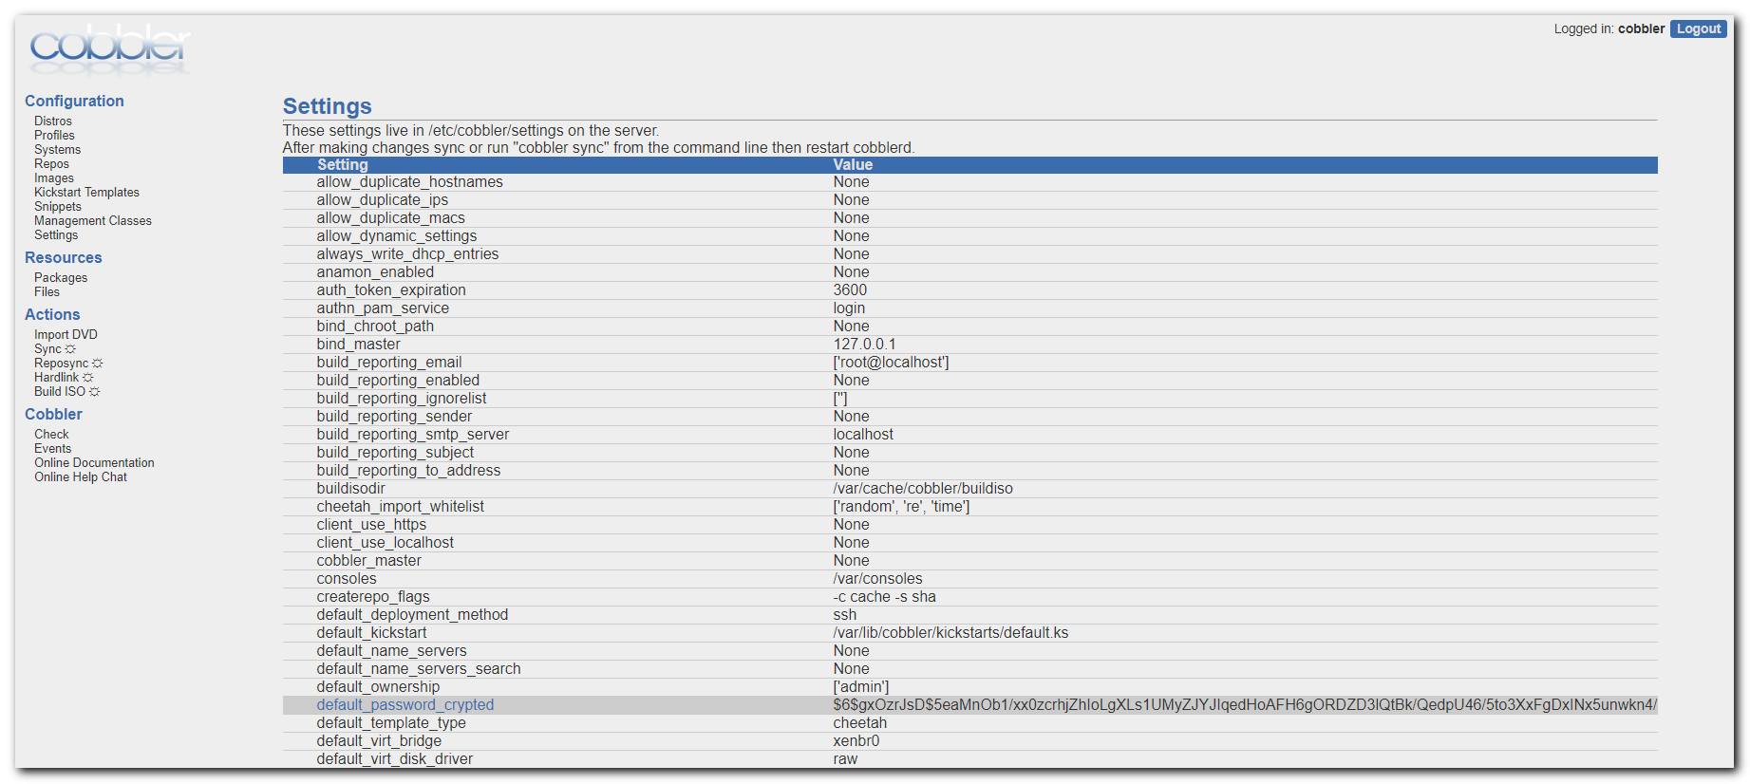

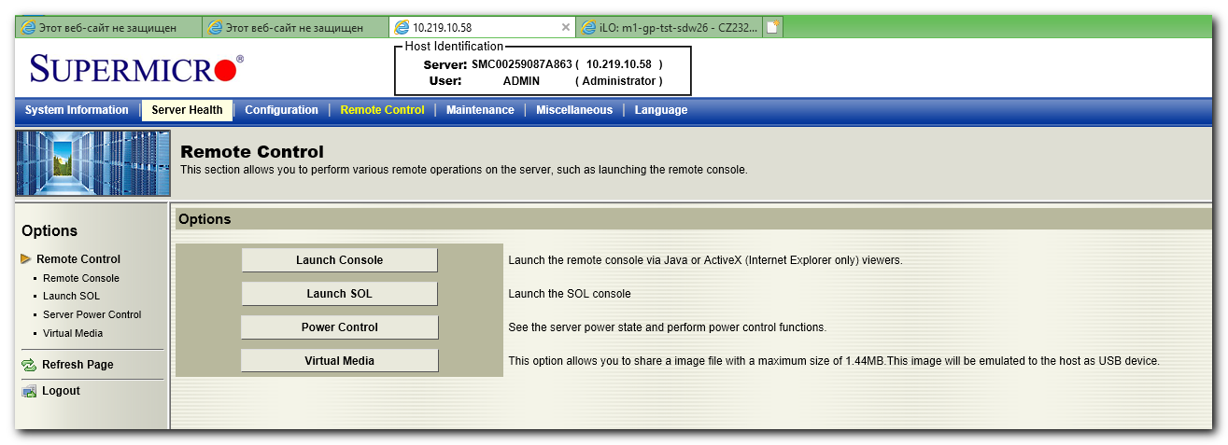

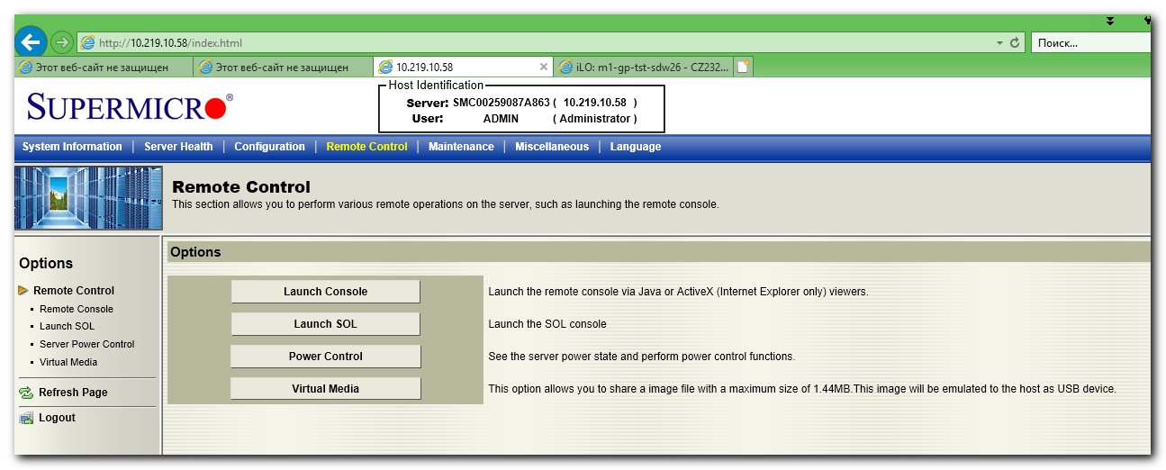

# It required to force boot from network - here available F12 button.
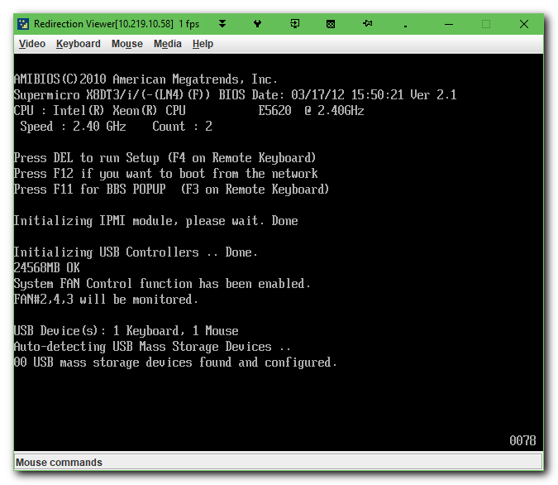

#
# How looks HDD configuration for this server.
# It’s available in raid confg if was pressed Ctrl+A buttons combination during server boot.
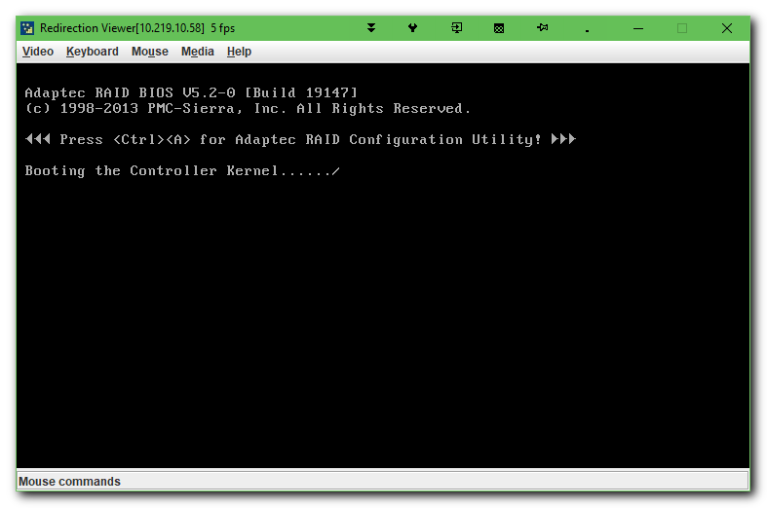
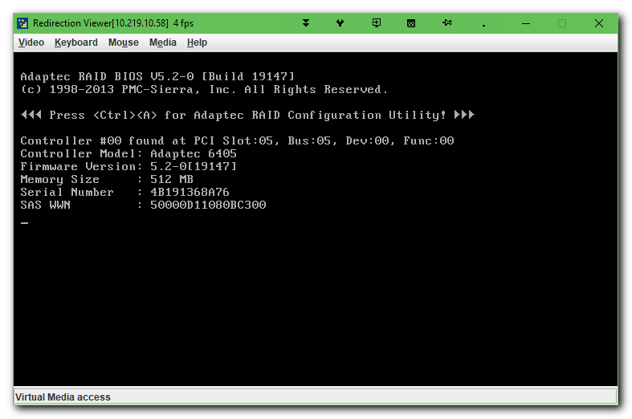
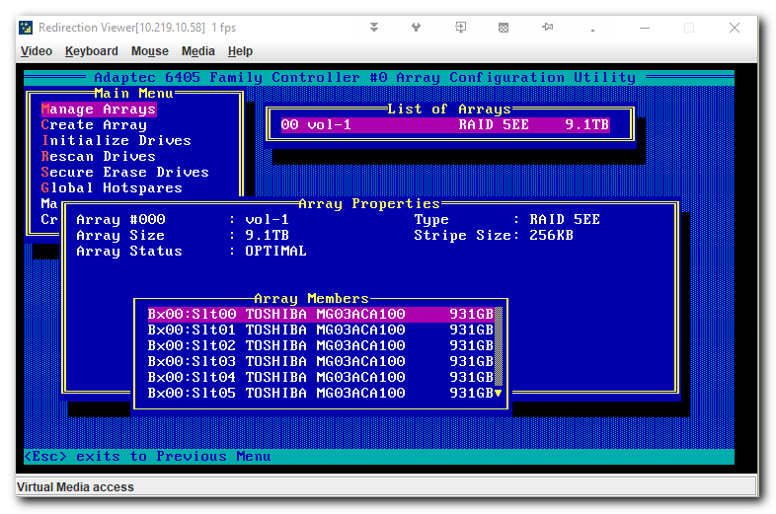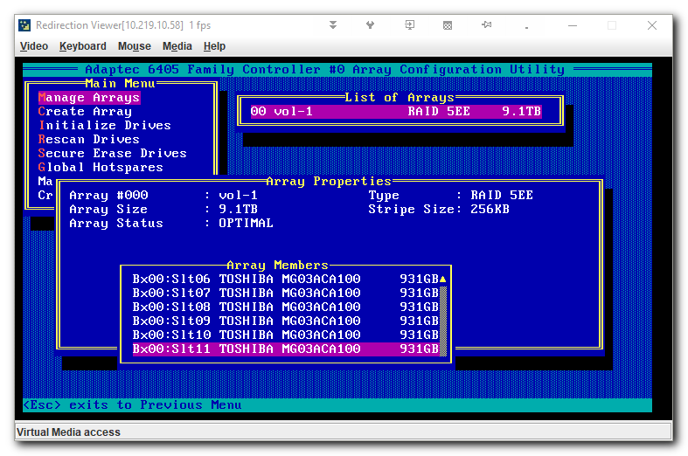
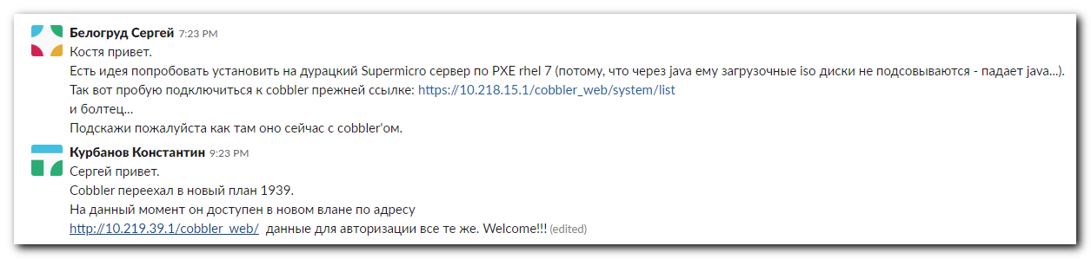

#
# Here is common info about motherboard, cpu, memory installed in this server chassie.
# Was pressed DEL of F4 button during server boot.
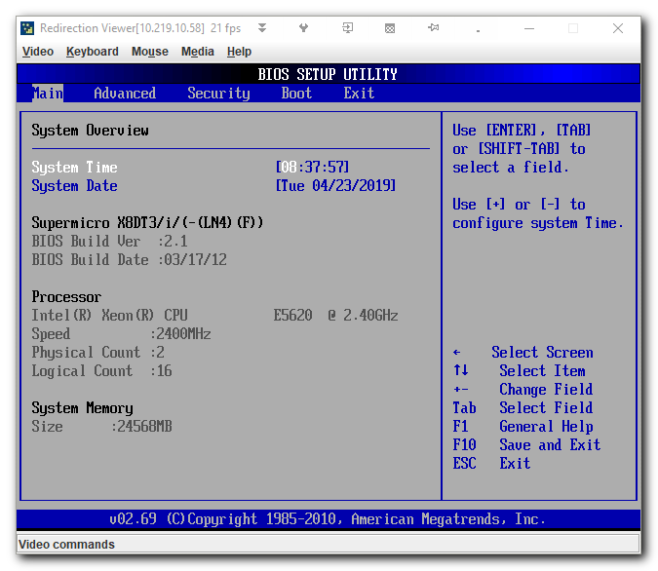
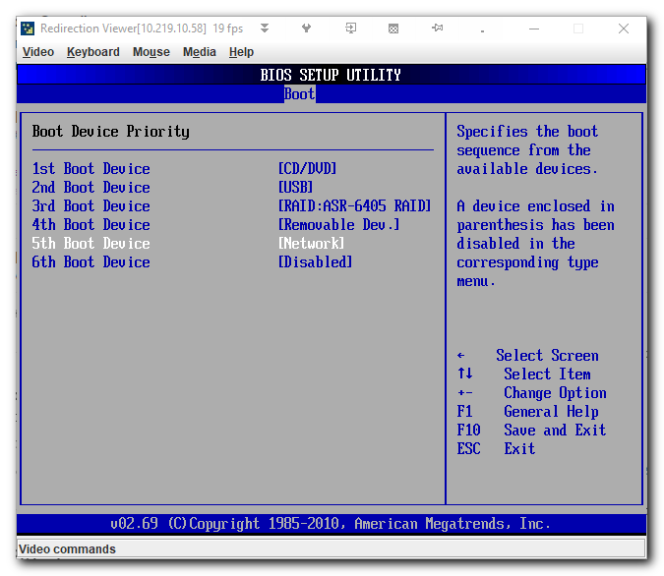
#
# Here we can see, that network devices are not available for boot.
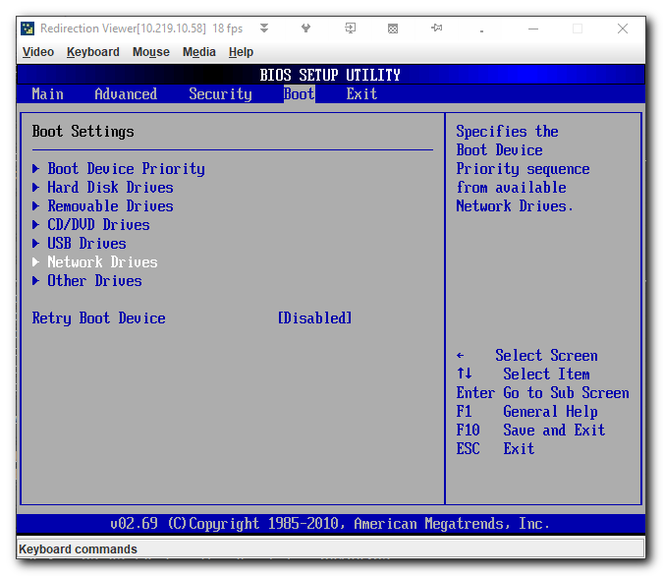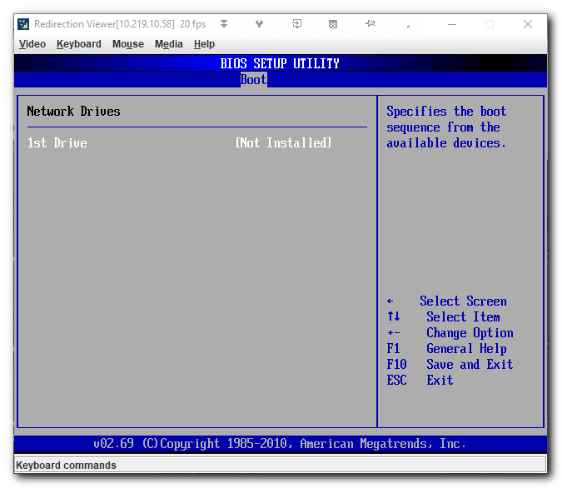

# Here is how looks like boot procedure at this moment.
# Only available boot from raid.
# Was pressed F11 or F3 button to see this menu.
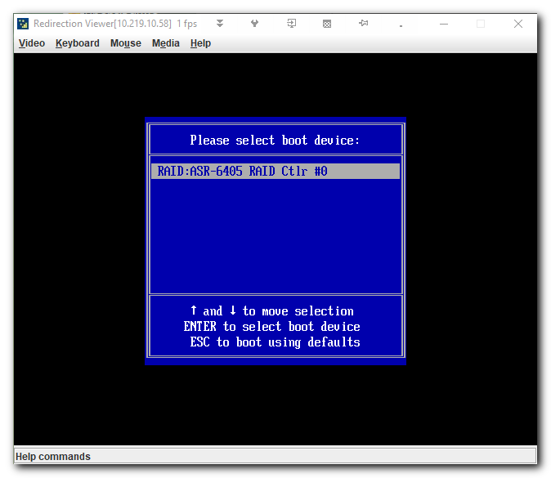

#
# To enable use boot via network devices, it’s need to Enable it here.
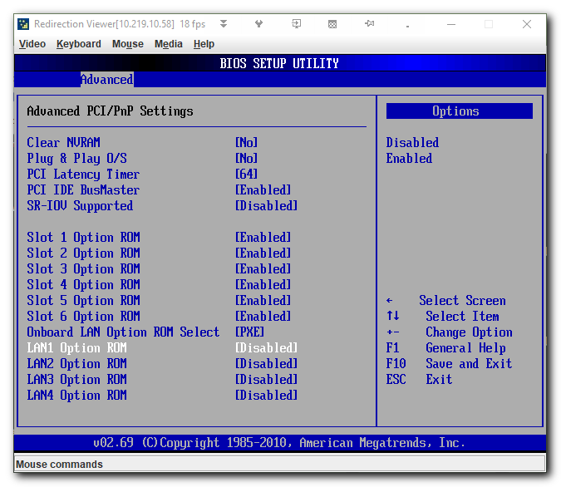

# Now network devices are Enabled for boot.
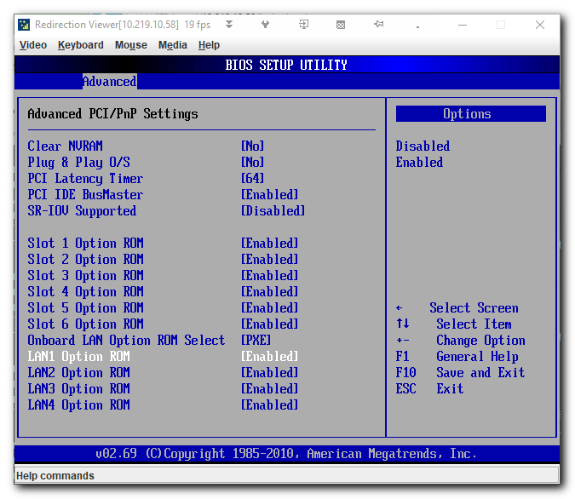
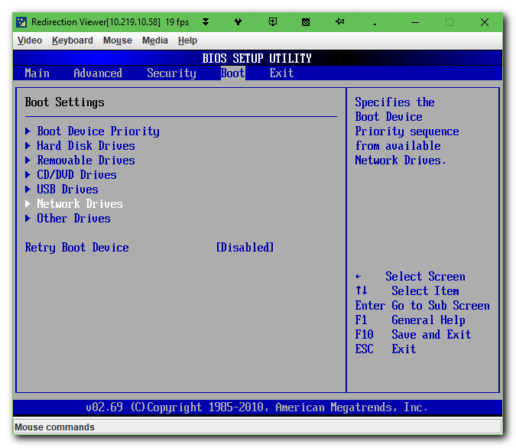
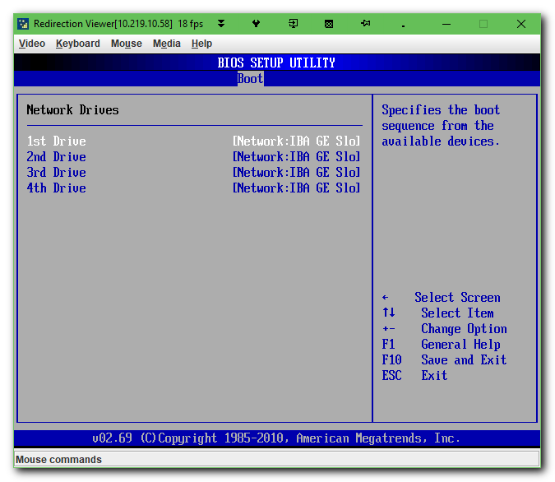

#
# To be sure, I temporary have changed boot sequence to boot from network device first.
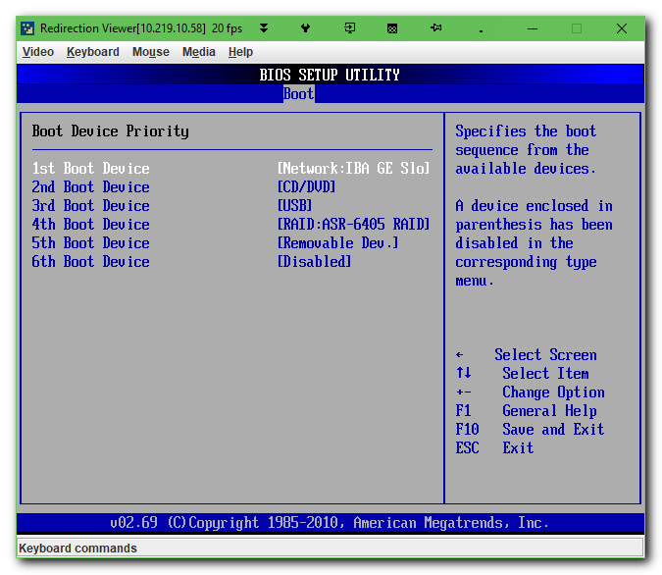

# Here is how looks boot, after PXE start working.

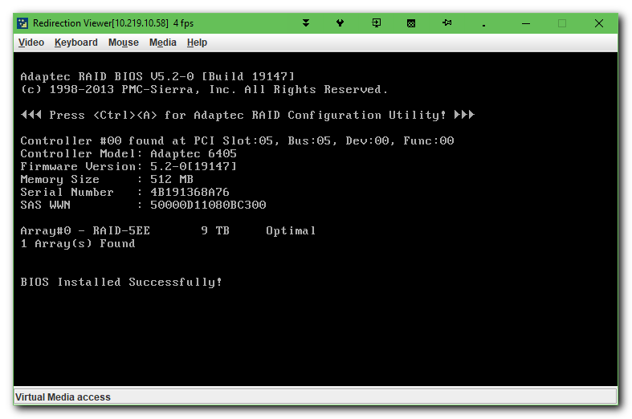

# I don’t know what exactly do Ctrl+S button combination. I’ve not tried it.
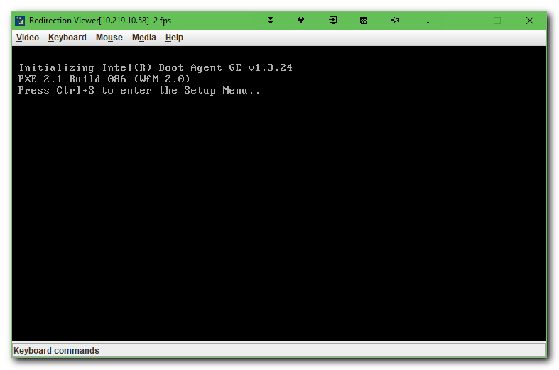
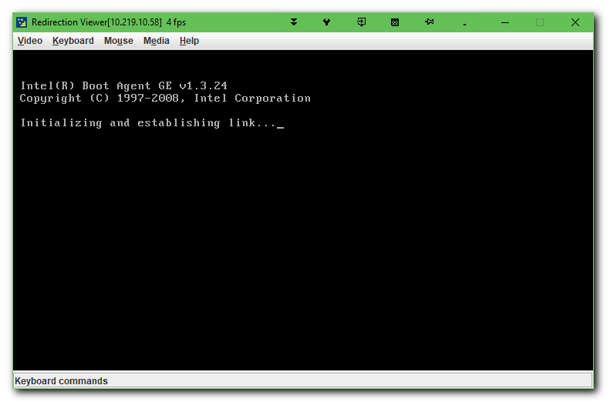

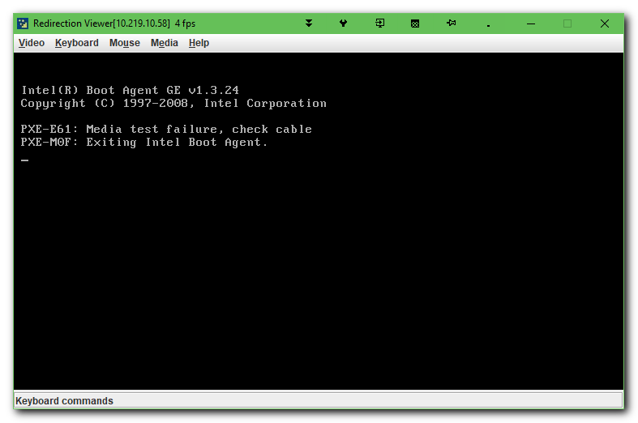
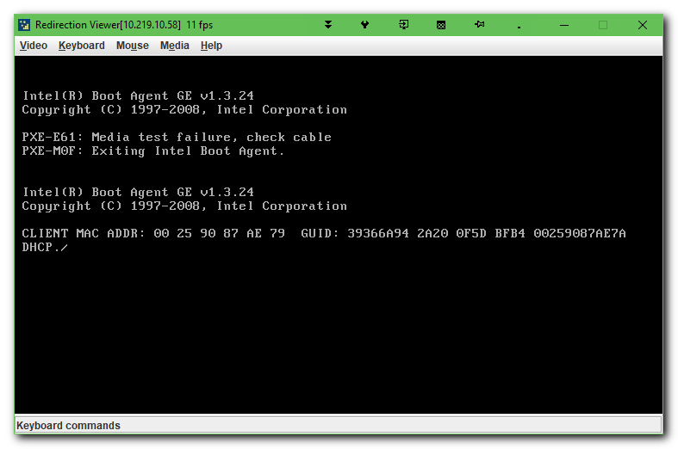

# When PXE started working, I’ve seen on server vm-pxe01p in /var/log/messages follow string during server boot.
#
...
Apr 23 15:48:26 vm-pxe01p dhcpd: DHCPDISCOVER from 00:25:90:87:ae:79 via eth1
Apr 23 15:48:27 vm-pxe01p dhcpd: DHCPOFFER on 10.219.39.150 to 00:25:90:87:ae:79 via eth1
Apr 23 15:48:34 vm-pxe01p dhcpd: DHCPDISCOVER from 00:25:90:87:ae:79 via eth1
Apr 23 15:48:34 vm-pxe01p dhcpd: DHCPOFFER on 10.219.39.150 to 00:25:90:87:ae:79 via eth1
Apr 23 15:48:42 vm-pxe01p dhcpd: Wrote 0 deleted host decls to leases file.
Apr 23 15:48:42 vm-pxe01p dhcpd: Wrote 0 new dynamic host decls to leases file.
Apr 23 15:48:42 vm-pxe01p dhcpd: Wrote 4 leases to leases file.
Apr 23 15:48:42 vm-pxe01p dhcpd: DHCPREQUEST for 10.219.39.150 (10.219.39.1) from 00:25:90:87:ae:79 via eth1
Apr 23 15:48:42 vm-pxe01p dhcpd: DHCPACK on 10.219.39.150 to 00:25:90:87:ae:79 via eth1
Apr 23 15:48:42 vm-pxe01p systemd: Started Tftp Server.
Apr 23 15:48:42 vm-pxe01p systemd: Starting Tftp Server...
Apr 23 15:48:42 vm-pxe01p in.tftpd[17830]: tftp: client does not accept options
Apr 23 15:48:42 vm-pxe01p in.tftpd[17831]: Client 10.219.39.150 finished /pxelinux.0
Apr 23 15:48:42 vm-pxe01p in.tftpd[17842]: Client 10.219.39.150 finished /pxelinux.cfg/default
Apr 23 15:48:42 vm-pxe01p in.tftpd[17847]: Client 10.219.39.150 finished /menu.c32
Apr 23 15:48:42 vm-pxe01p in.tftpd[17848]: Client 10.219.39.150 finished /pxelinux.cfg/default
...

# This menu was taken from cobbler host.
# Default is to boot from local HDD or other devices.
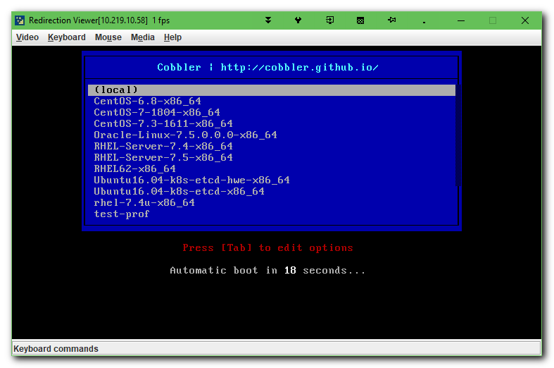

# I’ve choosed to boot and install rhel 7.5.
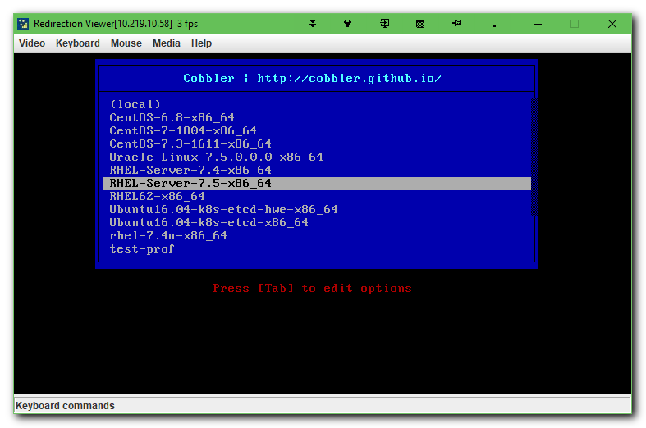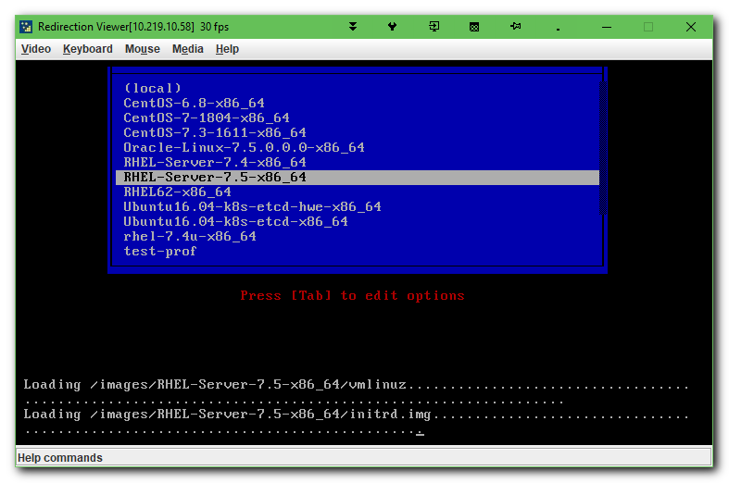

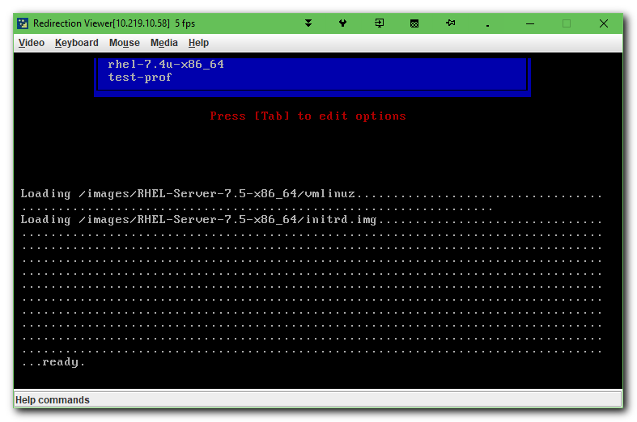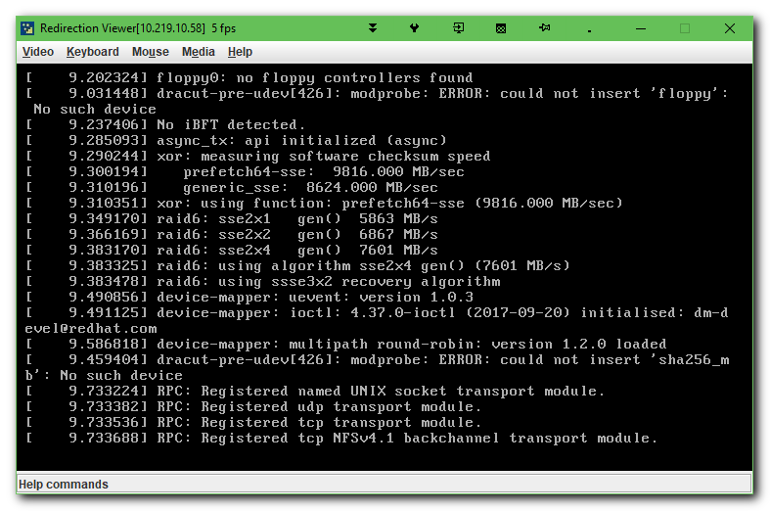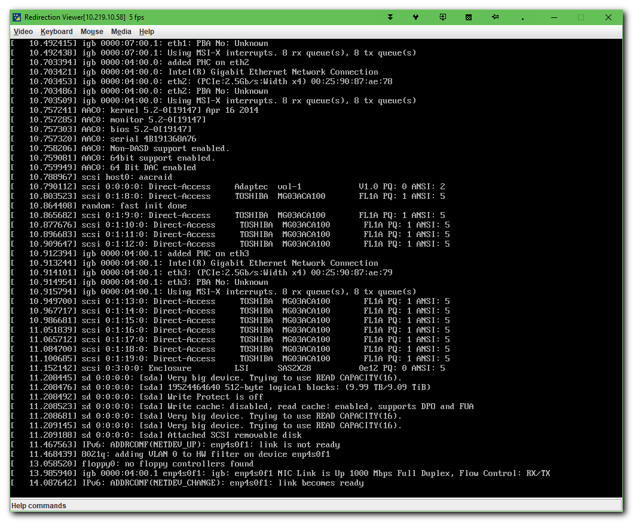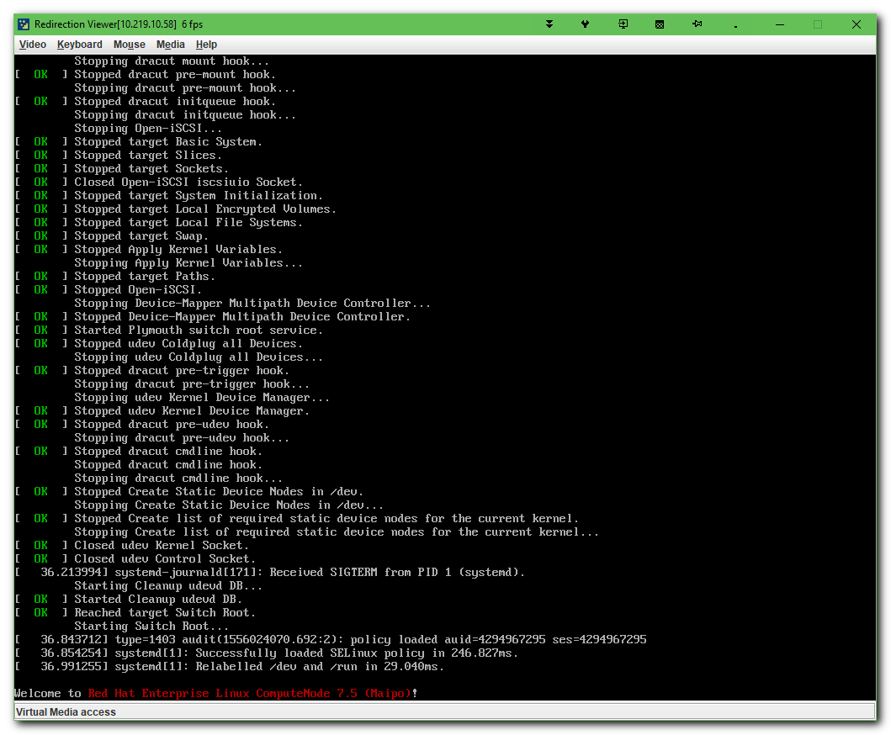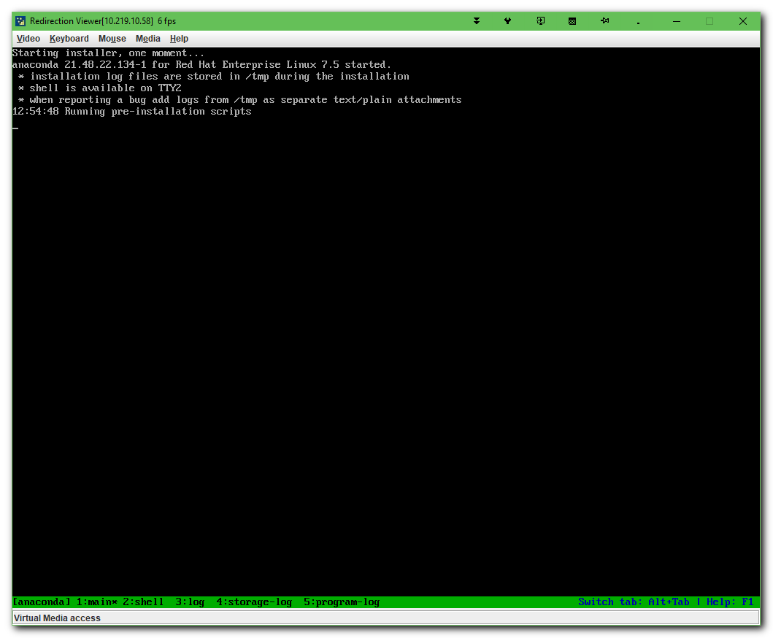

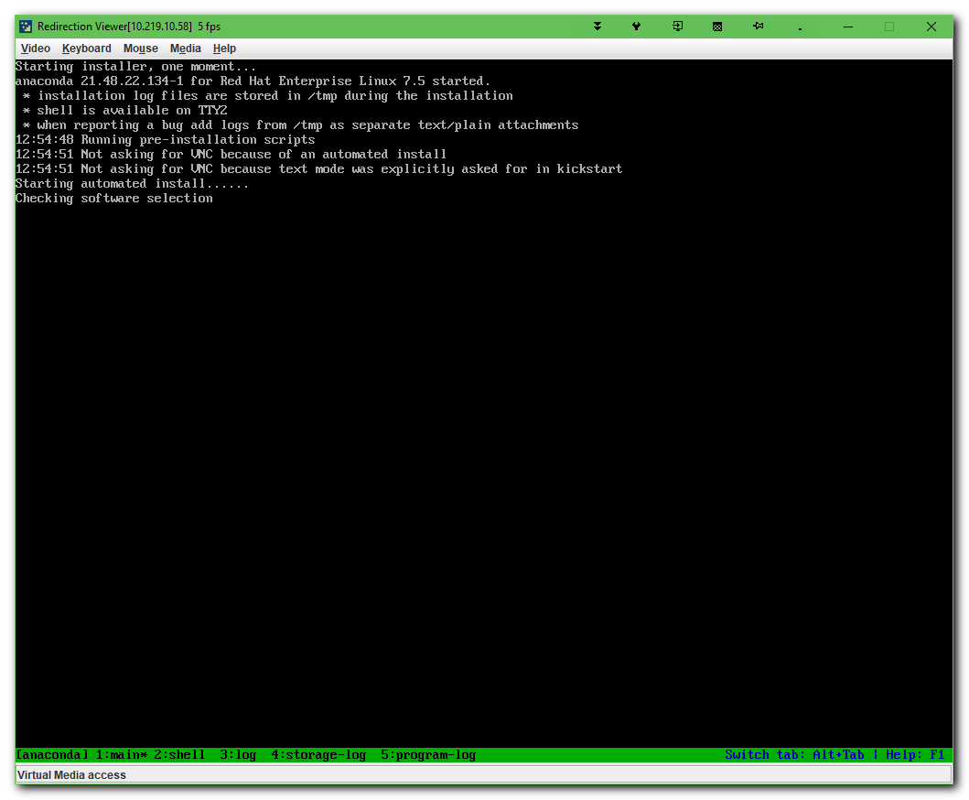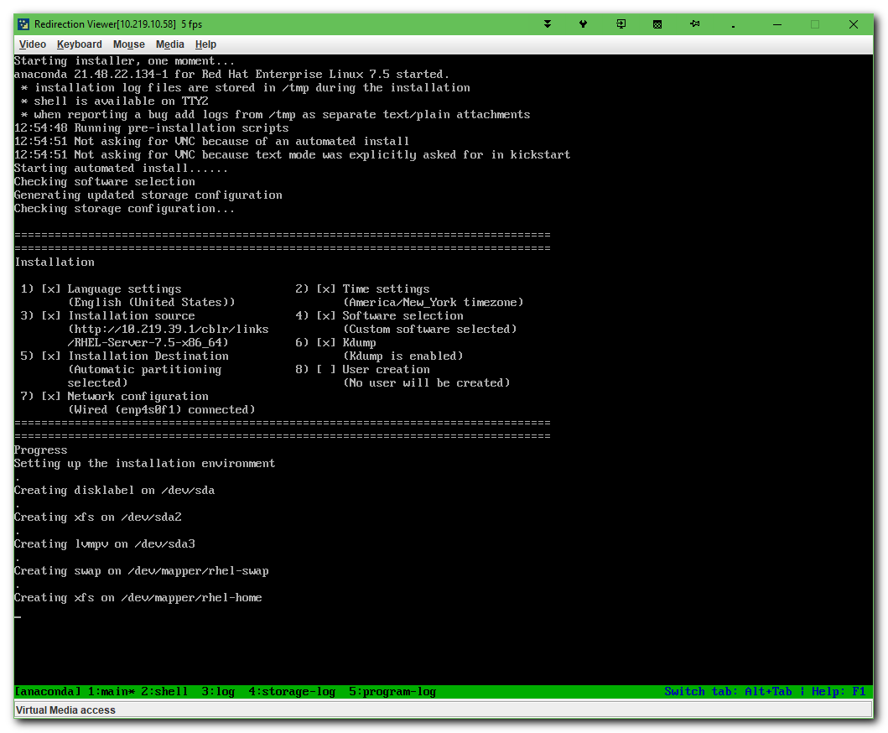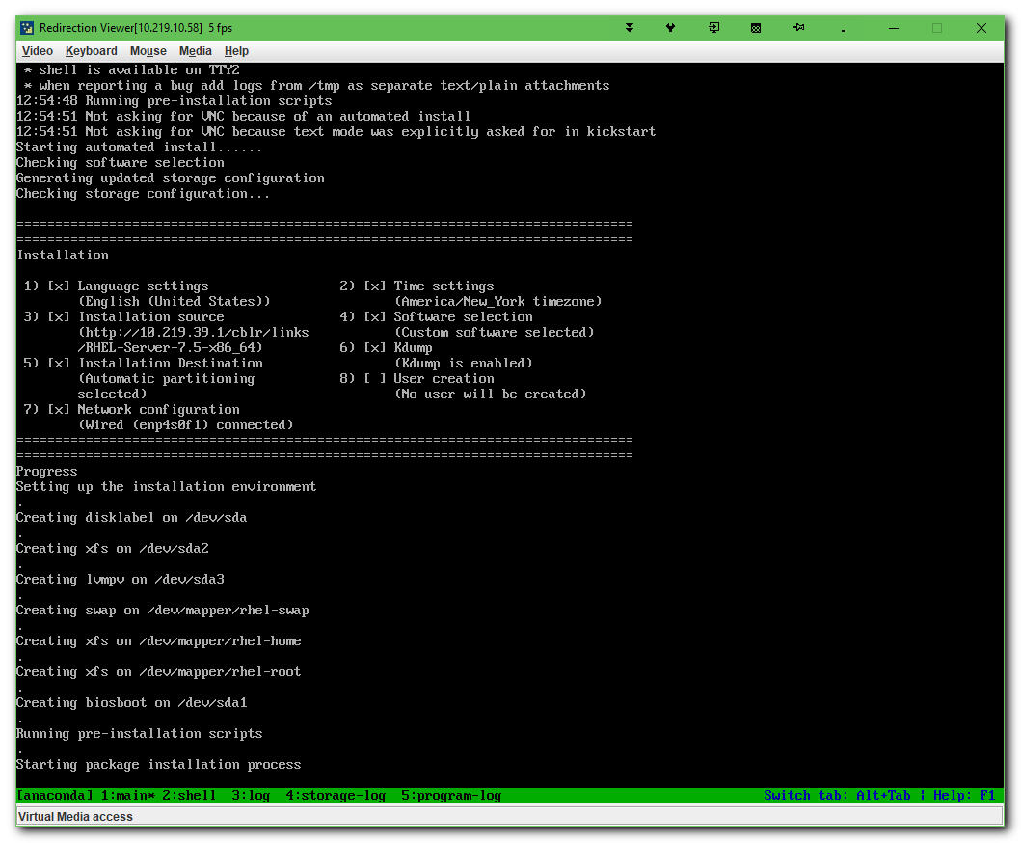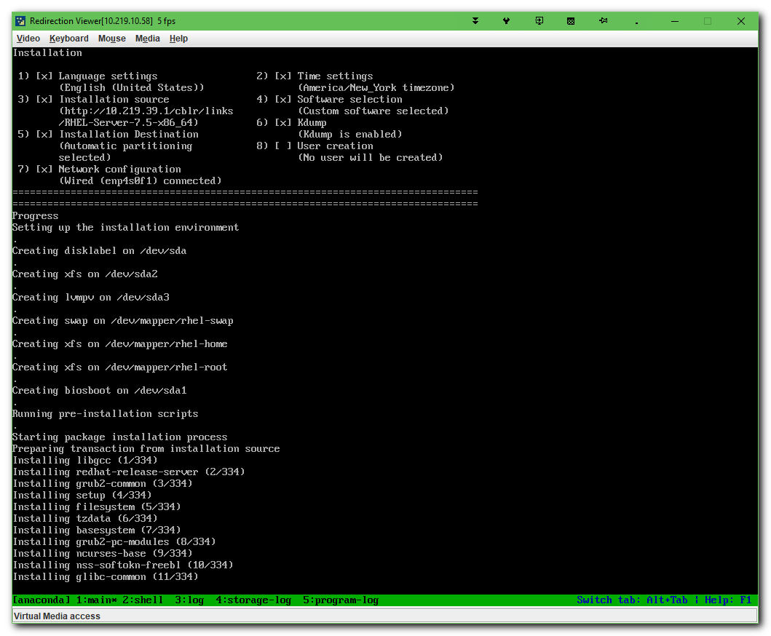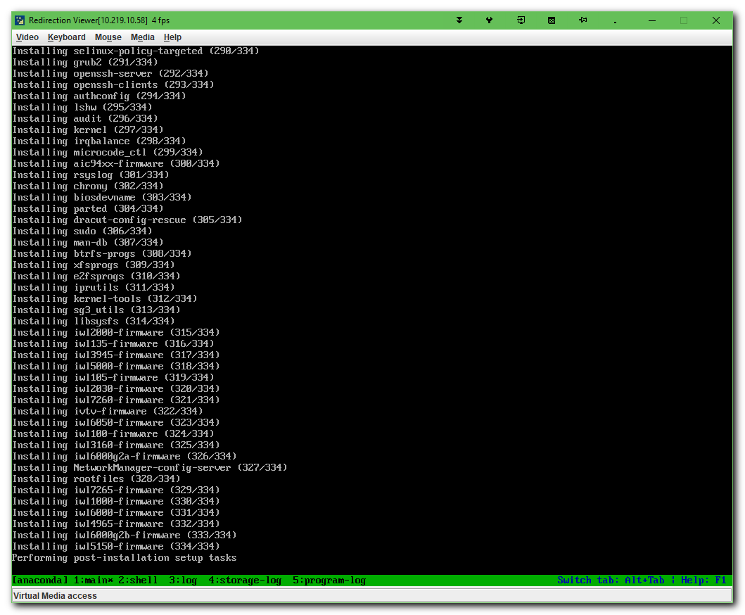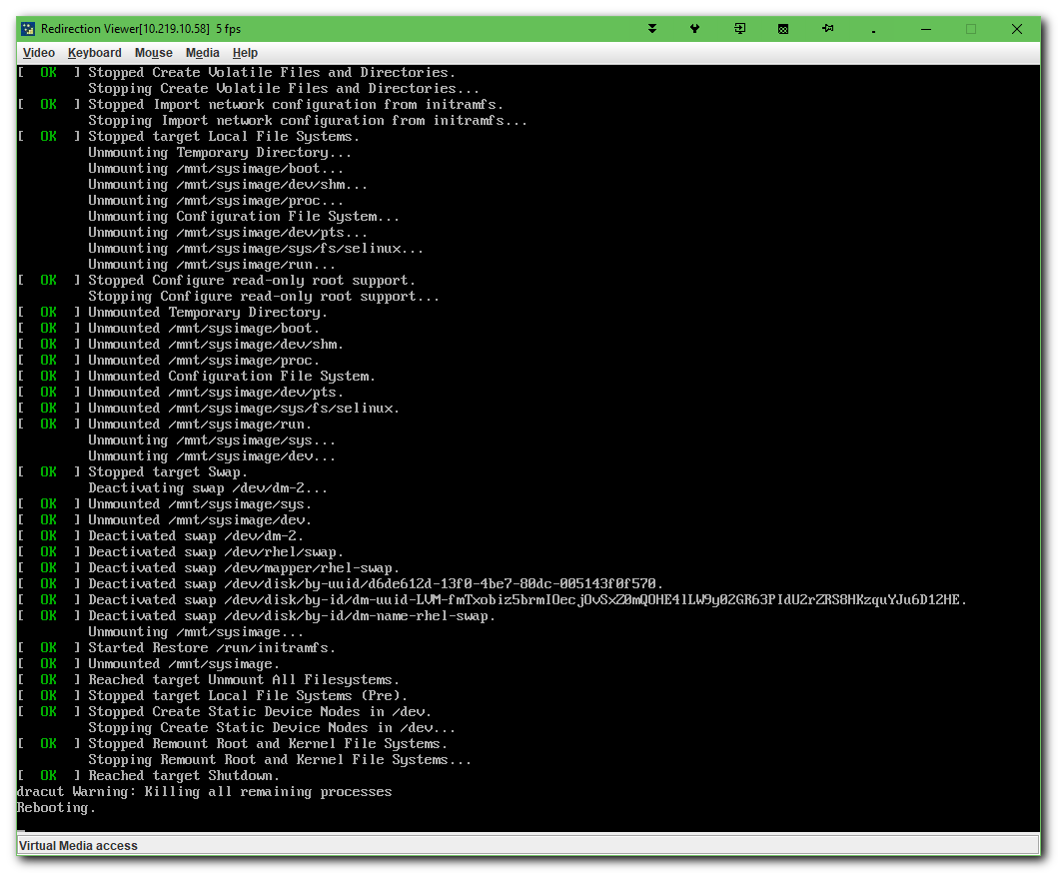

# After successful installed OS, I’ve turned back boot configuration.
# Boot from network was moved to last.
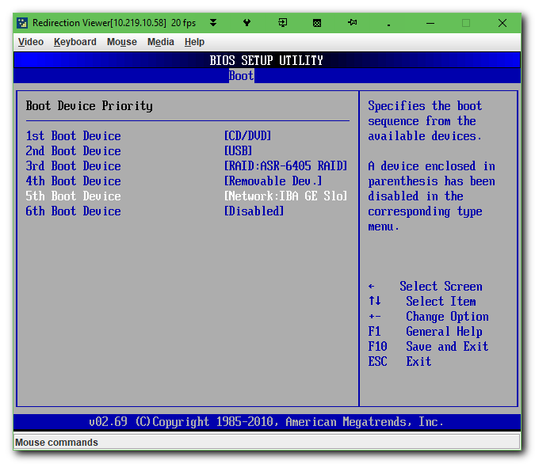

# There was not known root password, when I’ve installed OS.
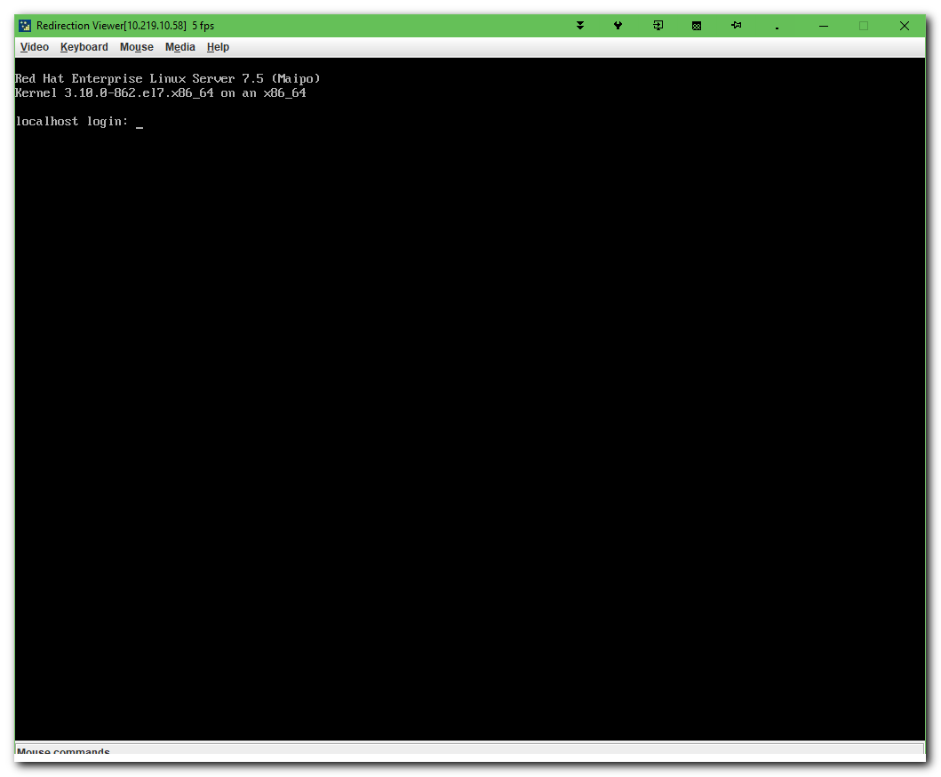

# This trick was not helped me. Because even in single mode was requested to enter password for root user.
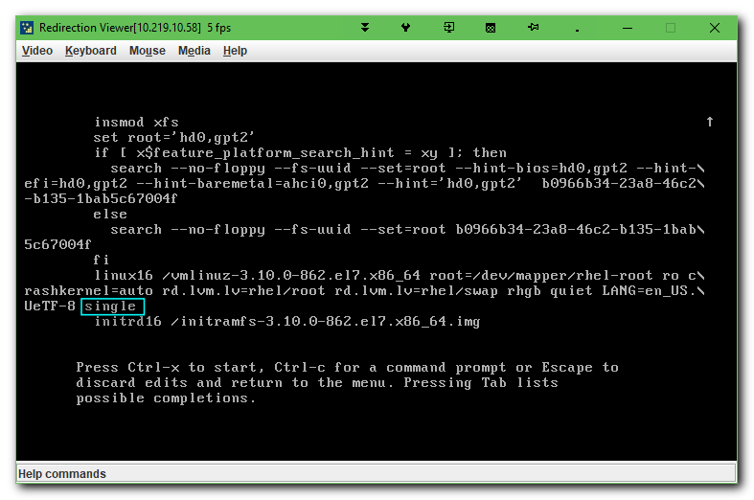

# This option was helped me.
https://www.rootusers.com/how-to-reset-root-user-password-in-centos-rhel-7/
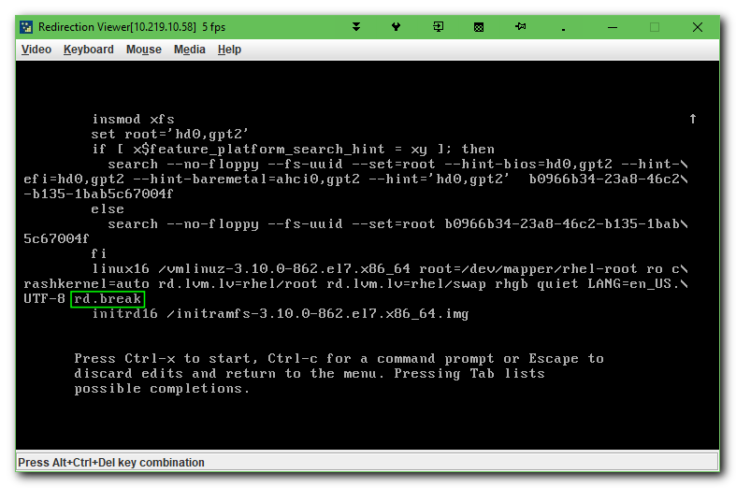

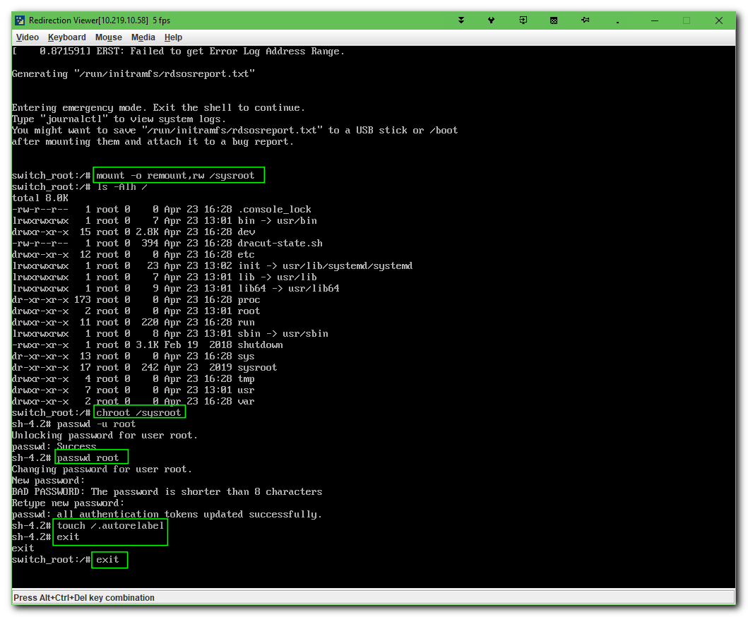

# After exiting, server didn’t reboot. It was continue to boot and allow to login.
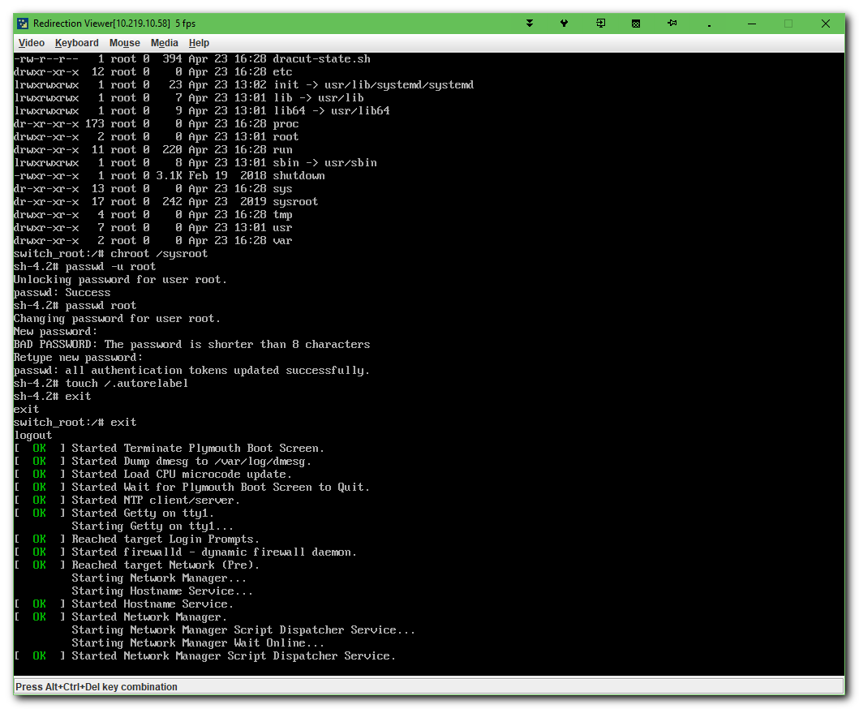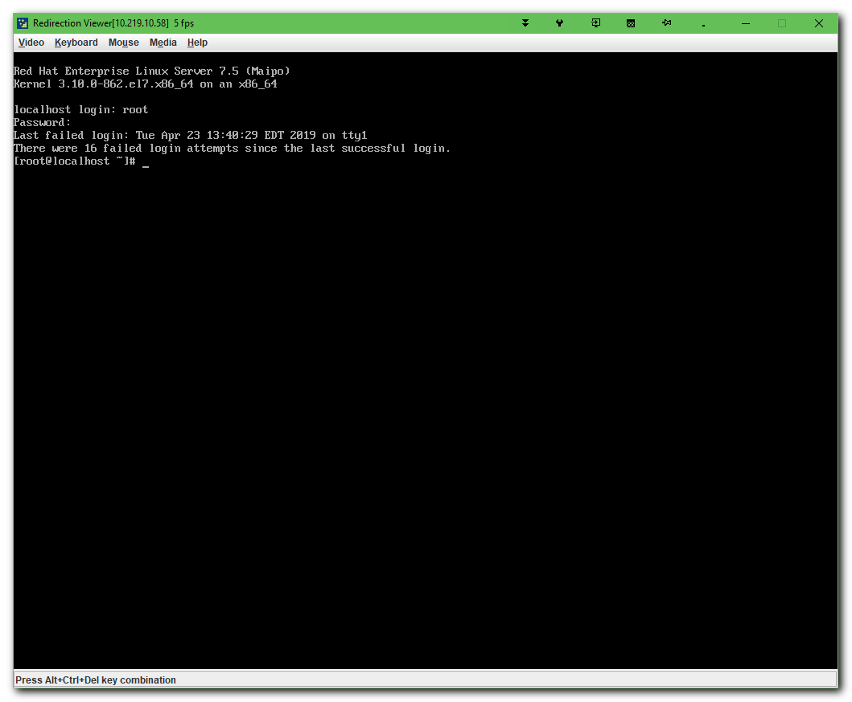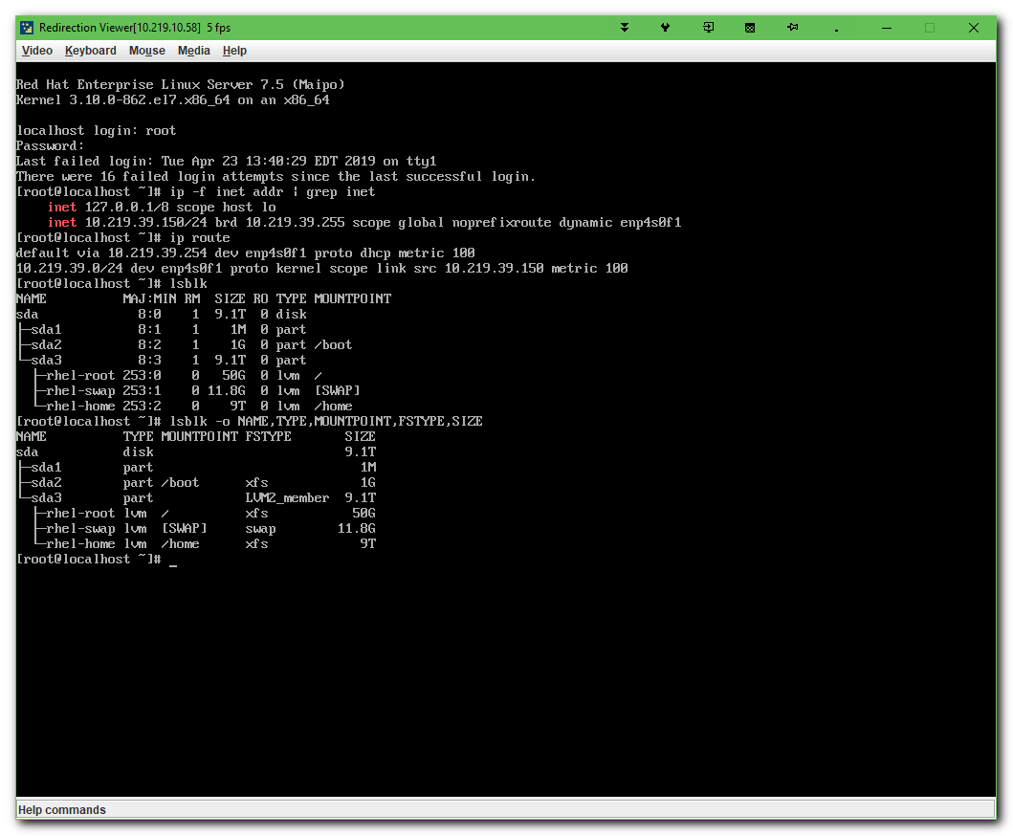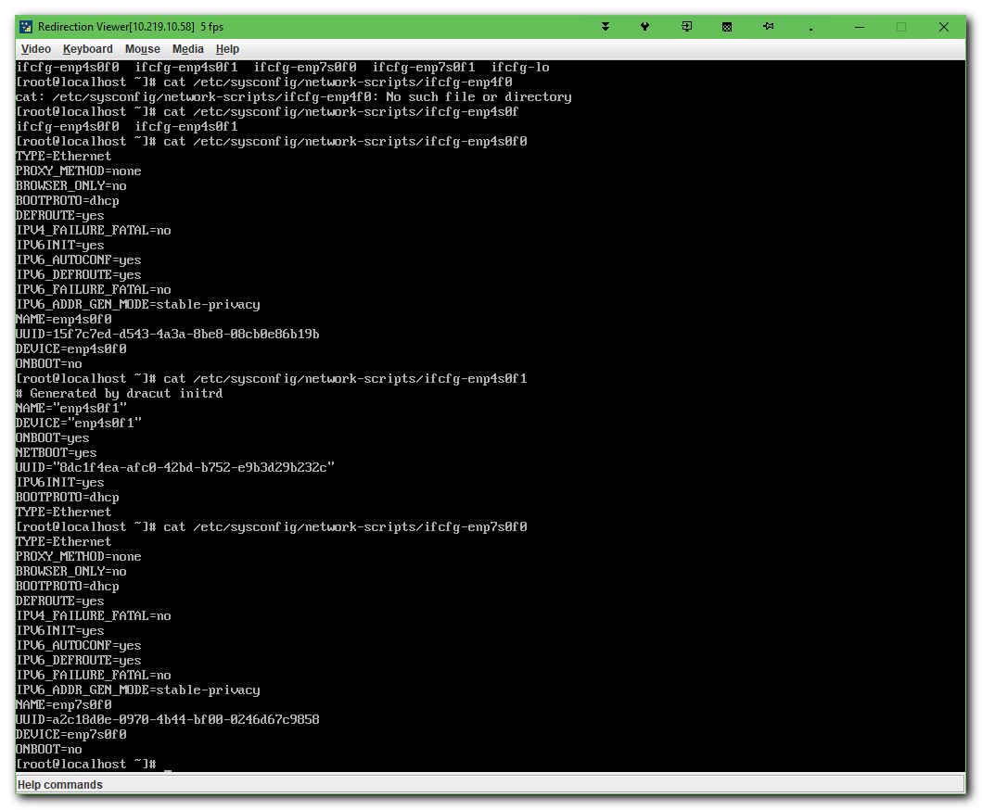

[s.belogrud@TCS4357]# ssh root@10.219.39.150
Warning: Permanently added '10.219.39.150' (RSA) to the list of known hosts.
root@10.219.39.150's password:
Last login: Tue Apr 23 16:32:43 2019
[root@localhost ~]#

[root@localhost ~]# cat /etc/redhat-release
Red Hat Enterprise Linux Server release 7.5 (Maipo)
[root@localhost ~]#

[root@localhost ~]# ip -f inet addr | grep inet
inet 127.0.0.1/8 scope host lo
inet 10.219.39.150/24 brd 10.219.39.255 scope global noprefixroute dynamic enp4s0f1
[root@localhost ~]# ip route
default via 10.219.39.254 dev enp4s0f1 proto dhcp metric 100
10.219.39.0/24 dev enp4s0f1 proto kernel scope link src 10.219.39.150 metric 100
[root@localhost ~]#

[root@localhost ~]# lsblk -o NAME,TYPE,MOUNTPOINT,FSTYPE,SIZE
NAME TYPE MOUNTPOINT FSTYPE SIZE
sda disk 9.1T
├─sda1 part 1M
├─sda2 part /boot xfs 1G
└─sda3 part LVM2_member 9.1T
├─rhel-root lvm / xfs 50G
├─rhel-swap lvm [SWAP] swap 11.8G
└─rhel-home lvm /home xfs 9T
[root@localhost ~]#

[root@localhost ~]# find /etc/sysconfig/network-scripts/ -name ifcfg-\* -exec echo \; -exec echo {} \; -exec cat {} \; | less

/etc/sysconfig/network-scripts/ifcfg-lo
DEVICE=lo
IPADDR=127.0.0.1
NETMASK=255.0.0.0
NETWORK=127.0.0.0
# If you're having problems with gated making 127.0.0.0/8 a martian,
# you can change this to something else (255.255.255.255, for example)
BROADCAST=127.255.255.255
ONBOOT=yes
NAME=loopback

/etc/sysconfig/network-scripts/ifcfg-enp7s0f1
TYPE=Ethernet
PROXY_METHOD=none
BROWSER_ONLY=no
BOOTPROTO=dhcp
DEFROUTE=yes
IPV4_FAILURE_FATAL=no
IPV6INIT=yes
IPV6_AUTOCONF=yes
IPV6_DEFROUTE=yes
IPV6_FAILURE_FATAL=no
IPV6_ADDR_GEN_MODE=stable-privacy
NAME=enp7s0f1
UUID=8ab5e7b9-8e78-4eed-8530-a3161a079ab5
DEVICE=enp7s0f1
ONBOOT=no

/etc/sysconfig/network-scripts/ifcfg-enp4s0f0
TYPE=Ethernet
PROXY_METHOD=none
BROWSER_ONLY=no
BOOTPROTO=dhcp
DEFROUTE=yes
IPV4_FAILURE_FATAL=no
IPV6INIT=yes
IPV6_AUTOCONF=yes
IPV6_DEFROUTE=yes
IPV6_FAILURE_FATAL=no
IPV6_ADDR_GEN_MODE=stable-privacy
NAME=enp4s0f0
UUID=15f7c7ed-d543-4a3a-8be8-08cb0e86b19b
DEVICE=enp4s0f0
ONBOOT=no

/etc/sysconfig/network-scripts/ifcfg-enp4s0f1
# Generated by dracut initrd
NAME="enp4s0f1"
DEVICE="enp4s0f1"
ONBOOT=yes
NETBOOT=yes
UUID="8dc1f4ea-afc0-42bd-b752-e9b3d29b232c"
IPV6INIT=yes
BOOTPROTO=dhcp
TYPE=Ethernet

/etc/sysconfig/network-scripts/ifcfg-enp7s0f0
TYPE=Ethernet
PROXY_METHOD=none
BROWSER_ONLY=no
BOOTPROTO=dhcp
DEFROUTE=yes
IPV4_FAILURE_FATAL=no
IPV6INIT=yes
IPV6_AUTOCONF=yes
IPV6_DEFROUTE=yes
IPV6_FAILURE_FATAL=no
IPV6_ADDR_GEN_MODE=stable-privacy
NAME=enp7s0f0
UUID=a2c18d0e-0970-4b44-bf00-0246d67c9858
DEVICE=enp7s0f0
ONBOOT=no

https://www.rootusers.com/how-to-reset-root-user-password-in-centos-rhel-7/

How To Reset Root User Password In CentOS/RHEL 7
Posted by Jarrod on September 14, 2016
Leave a comment (31)
Go to comments
Normally resetting the root password is a simple task if you’re logged in already with root privileges, however if you forget the password and need to change it things become a little more difficult.
The process has changed from CentOS/RHEL (Red Hat Enterprise Linux) version 6 to 7, as previously you would boot into single user mode and then change the password as root. From version 7 the equivalent modes are the rescue or emergency targets, however these require the root password before you can do anything which doesn’t help us here, so we’ll take you through the new process to change the lost root password.
This is also a task that you will need to know how to perform for the RHCSA exam.
This procedure will be completed in the console of the Linux system, so be sure that you have access to this prior to beginning. As with all system maintenance tasks, be sure you have a system backup/snapshot prior to proceeding.
- If your Linux system is currently running, reboot it. If it is not yet running, start it up. At the boot menu, press the ‘e’ key to edit the first boot entry.
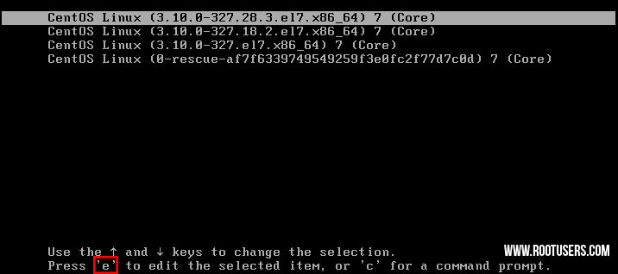
- From the grub options, find the line that starts with “linux16” and go to the end of it. Enter ‘rd.break’ without quotes at the end of this line, as shown below.
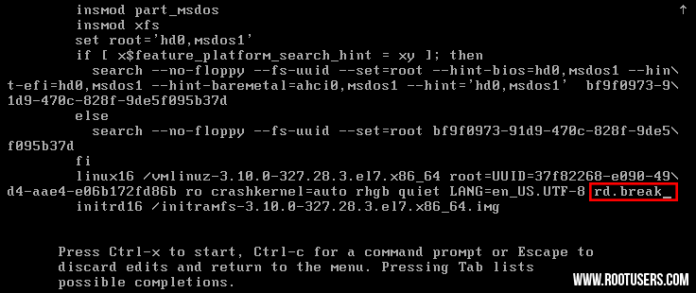
- Press “Ctrl+x” to boot with these options. This will boot to the initramfs prompt with a root shell.
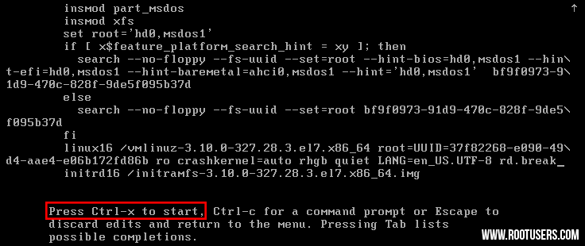
- At this stage, the root file system is mounted in read only mode to /sysroot and must be remounted with read/write (rw) permissions in order for us to actually make any changes. This is done with the ‘mount -o remount,rw /sysroot’ command.
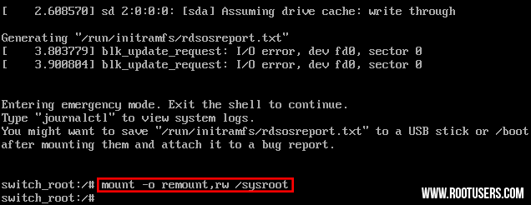
- Once the file system has been remounted, change into a chroot jail so that /sysroot is used as the root of the file system. This is required so that any further commands we run will be in regards to /sysroot. This is done by running ‘chroot /sysroot’.
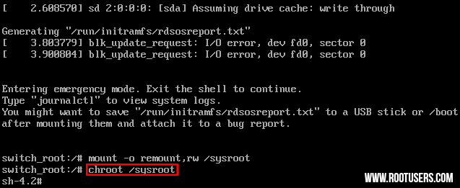
- From here the root password can be reset with the ‘passwd’ command.
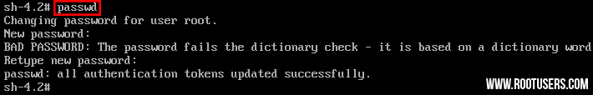
- If you’re not using SELinux, you could reboot at this point and everything would be fine, however by default CentOS/RHEL 7 use SELinux in enforcing mode, so we need to fix the context of the /etc/shadow file. This is because when the ‘passwd’ command is run, it creates a new /etc/shadow file. As SELinux is not running in this mode the file is created with no SELinux contexts, which can cause problems when we reboot. Create the /.autorelabel command using ‘touch’.
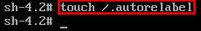
Creating this file will automatically perform a relabel of all files on next boot. Note that this may take some time depending on the amount of files you have on the file system. For a plain vanilla CentOS 7 server, it takes me about 2 minutes to complete.
- Enter the ‘exit’ command twice, the first one will exit the chroot jail environment while the second will exit the initramfs root shell and reboot the system.
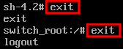
Once the reboot has completed you will be able to use the root account with your newly set password.

Summary
As shown we can reset the root password in Linux CentOS/RHEL 7 by booting with the ‘rd.break’ option, remounting the file system with read/write privileges, creating a chroot jail, executing the passwd command and then finally fixing up SELinux contexts.
After exiting the chroot and the initramfs root shell prompt the file system will be relabelled which may take a few minutes or more depending on the number of files you have. When your system has booted back up you’ll be able to use the new root password.

https://www.itzgeek.com/how-tos/linux/centos-how-tos/change-hostname-in-centos-7-rhel-7.html

[s.belogrud@TCS4357]# ssh root@10.216.103.16
Last login: Thu Apr 25 15:44:47 2019 from tcs4357.tcsbank.ru
[root@localhost ~]# vim /etc/selinux/config
[root@localhost ~]# hostnamectl status
Static hostname: localhost.localdomain
Icon name: computer-desktop
Chassis: desktop
Machine ID: 7ec0861595e54b69bd3620841a0f3db8
Boot ID: 76aeae7cf04c4414958d1754d25e28cd
Operating System: Red Hat Enterprise Linux Server 7.5 (Maipo)
CPE OS Name: cpe:/o:redhat:enterprise_linux:7.5:GA:server
Kernel: Linux 3.10.0-862.el7.x86_64
Architecture: x86-64
[root@localhost ~]# hostnamectl set-hostname ds-soc-tst.tcsbank.ru
[root@localhost ~]# hostnamectl status
Static hostname: ds-soc-tst.tcsbank.ru
Icon name: computer-desktop
Chassis: desktop
Machine ID: 7ec0861595e54b69bd3620841a0f3db8
Boot ID: 76aeae7cf04c4414958d1754d25e28cd
Operating System: Red Hat Enterprise Linux Server 7.5 (Maipo)
CPE OS Name: cpe:/o:redhat:enterprise_linux:7.5:GA:server
Kernel: Linux 3.10.0-862.el7.x86_64
Architecture: x86-64
[root@localhost ~]#
[root@ds-soc-tst ~]# hostname
ds-soc-tst.tcsbank.ru
[root@ds-soc-tst ~]# cat /etc/hostname
ds-soc-tst.tcsbank.ru
[root@ds-soc-tst ~]#

................................................................................

[root@localhost ~]# systemctl status puppet
? puppet.service - Puppet agent
Loaded: loaded (/usr/lib/systemd/system/puppet.service; disabled; vendor preset: disabled)
Active: active (running) since Thu 2019-04-25 15:47:25 EDT; 2min 33s ago
Main PID: 4715 (puppet)
CGroup: /system.slice/puppet.service
L-4715 /opt/puppetlabs/puppet/bin/ruby /opt/puppetlabs/puppet/bin/puppet agent --no-daemonize

Apr 25 15:47:25 localhost.localdomain systemd[1]: Starting Puppet agent...
Apr 25 15:49:57 localhost.localdomain puppet-agent[4715]: Could not request certificate: The certificate retrieved from the master does not match the agent's private key. Did you forg...un as root?
Apr 25 15:49:57 localhost.localdomain puppet-agent[4715]: Certificate fingerprint: FC:DC:19:1F:FA:66:A1:13:6C:1C:DF:FE:33:B5:0B:CB:65:A9:B4:AD:BF:FF:E5:DC:81:E3:AC:0E:97:0F:C3:B7
Apr 25 15:49:57 localhost.localdomain puppet-agent[4715]: To fix this, remove the certificate from both the master and the agent and then start a puppet run, which will automatically ...ertificate.
Apr 25 15:49:57 localhost.localdomain puppet-agent[4715]: On the master:
Apr 25 15:49:57 localhost.localdomain puppet-agent[4715]: puppet cert clean localhost.localdomain
Apr 25 15:49:57 localhost.localdomain puppet-agent[4715]: On the agent:
Apr 25 15:49:57 localhost.localdomain puppet-agent[4715]: 1a. On most platforms: find /etc/puppetlabs/puppet/ssl -name localhost.localdomain.pem -delete
Apr 25 15:49:57 localhost.localdomain puppet-agent[4715]: 1b. On Windows: del "\etc\puppetlabs\puppet\ssl\certs\localhost.localdomain.pem" /f
Apr 25 15:49:57 localhost.localdomain puppet-agent[4715]: 2. puppet agent -t
Hint: Some lines were ellipsized, use -l to show in full.
[root@localhost ~]# systemctl stop puppet

[root@localhost ~]# date --set=1850
Thu Apr 25 18:50:00 EDT 2019
[root@localhost ~]# hwclock --systohc
[root@localhost ~]# find /etc/puppetlabs/puppet/ssl -name localhost.localdomain.pem -delete
[root@localhost ~]#

[root@ds-soc-tst ~]# puppet agent -t
Info: Creating a new SSL key for ds-soc-tst.tcsbank.ru
Info: csr_attributes file loading from /etc/puppetlabs/puppet/csr_attributes.yaml
Info: Creating a new SSL certificate request for ds-soc-tst.tcsbank.ru
Info: Certificate Request fingerprint (SHA256): E0:C5:50:12:15:8D:E2:59:FE:64:20:BD:DB:06:F1:AD:35:E6:9F:03:6D:FB:7A:05:35:BD:E0:4A:7E:28:5E:02
Exiting; no certificate found and waitforcert is disabled
[root@ds-soc-tst ~]#

[root@vm-puppetmaster02p ~]# puppet cert sign ds-soc-tst.tcsbank.ru
Signing Certificate Request for:
"ds-soc-tst.tcsbank.ru" (SHA256) E0:C5:50:12:15:8D:E2:59:FE:64:20:BD:DB:06:F1:AD:35:E6:9F:03:6D:FB:7A:05:35:BD:E0:4A:7E:28:5E:02
Notice: Signed certificate request for ds-soc-tst.tcsbank.ru
Notice: Removing file Puppet::SSL::CertificateRequest ds-soc-tst.tcsbank.ru at '/etc/puppetlabs/puppet/ssl/ca/requests/ds-soc-tst.tcsbank.ru.pem'
[root@vm-puppetmaster02p ~]#

https://www.supermicro.com/en/solutions/management-software/superdoctor
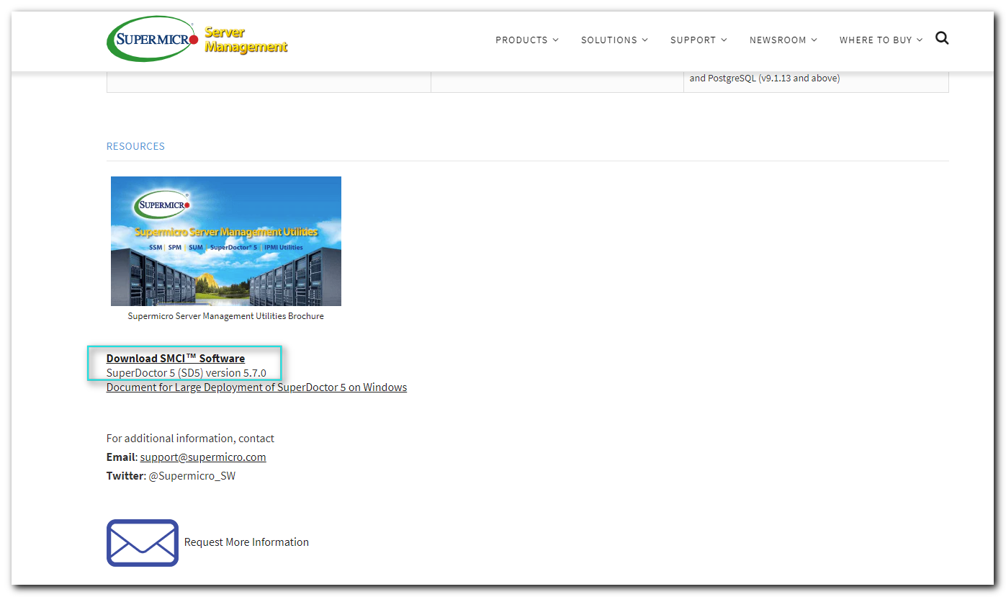

https://www.supermicro.com/SwDownload/SwSelect_Free.aspx?cat=SD5
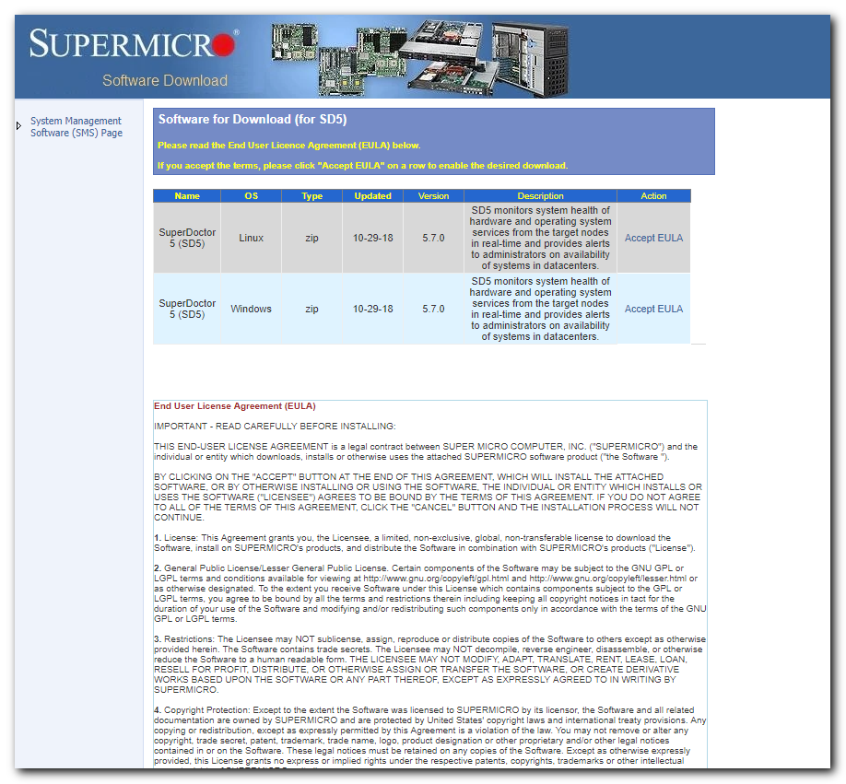

[s.belogrud@TCS4357]# scp /drives/c/Users/s.belogrud/Downloads/SD5_5.7.0_build.921_linux.zip bsv@ds-soc-tst:/tmp/
SD5_5.7.0_build.921_linux.zip 99% 148MB 18.5MB/s 00:08
[s.belogrud@TCS4357]#

[s.belogrud@TCS4357]# ssh bsv@ds-soc-tst
Last login: Fri Apr 26 05:04:07 2019 from tcs4357.tcsbank.ru
[bsv@ds-soc-tst ~]$ sudo -i
[sudo] password for bsv:
[root@ds-soc-tst ~]# mkdir ~/work/20190426-1459
[root@ds-soc-tst ~]# cp /tmp/SD5_5.7.0_build.921_linux.zip ~/work/20190426-1459/
[root@ds-soc-tst ~]# cd ~/work/20190426-1459/
[root@ds-soc-tst 20190426-1459]# ll
total 151632
-rwx------ 1 root root 155268641 Apr 26 07:59 SD5_5.7.0_build.921_linux.zip
[root@ds-soc-tst 20190426-1459]#

[root@ds-soc-tst 20190426-1459]# unzip SD5_5.7.0_build.921_linux.zip
Archive: SD5_5.7.0_build.921_linux.zip
inflating: ReleaseNote.txt
inflating: SD5_MIB.zip
inflating: SuperDoctor5Installer_5.7.0_build.921_linux_x64_20181018175405.bin
inflating: SuperDoctor5_UserGuide.pdf
inflating: crc32.txt
inflating: installer_agent.properties
[root@ds-soc-tst 20190426-1459]#

[root@ds-soc-tst 20190426-1459]# chmod +x SuperDoctor5Installer_5.7.0_build.921_linux_x64_20181018175405.bin

[root@ds-soc-tst 20190426-1459]# ./SuperDoctor5Installer_5.7.0_build.921_linux_x64_20181018175405.bin
Preparing to install
Extracting the JRE from the installer archive...
Unpacking the JRE...
Extracting the installation resources from the installer archive...
Configuring the installer for this system's environment...

Launching installer...

===============================================================================
SD5 (created with InstallAnywhere)
-------------------------------------------------------------------------------

Preparing CONSOLE Mode Installation...

===============================================================================
Introduction
------------

InstallAnywhere will guide you through the installation of SuperDoctor 5.

It is strongly recommended that you quit all programs before continuing with
this installation.

Respond to each prompt to proceed to the next step in the installation. If
you want to change something on a previous step, type 'back'.

You may cancel this installation at any time by typing 'quit'.

PRESS <ENTER> TO CONTINUE:

===============================================================================
License Agreement
-----------------

Installation and use of SuperDoctor 5 requires acceptance of the following
License Agreement:

The license distributed with SD5 (SuperDoctor 5) grants you the right to use
the SD5 software on a Supermicro product, subject to the restrictions listed
below and the disclaimer relating to warranties, support and damages.

1. DISCLAIMER: This software is provided on an "as is" basis, without any
other warranties, or conditions, express or implied, including but not limited
to warranties of merchantable quality, merchantability or fitness for a
particular purpose, or those arising by law, statute, usage of trade or course
of dealing. The entire risk as to the results and performance of the Product
is assumed by you. Neither we nor our dealers or suppliers shall have any
liability to you or any other person or entity for any indirect, incidental,
special or consequential damages whatsoever, including but not limited to loss
of revenue or profit, lost or damaged data or other commercial or economic
loss, even if we have been advised of the possibility of such damages or they
are foreseeable; or for claims by a third party. You may have other rights
which vary from state to state.

2. RESTRICTIONS: This license gives you the right to use this software but all
rights not specifically mentioned in this agreement, including ownership
rights, intellectual property rights, trademarks and copyright, are reserved
by Super Micro Computer Inc. You may not decompile, reverse engineer,
disassemble or otherwise reduce the software to a human perceivable form. You
may not modify, rent, lease, loan or resell for profit the software, or create

PRESS <ENTER> TO CONTINUE:

…
1. DISCLAIMER: This software is provided on an "as is" basis, without any
other warranties, or conditions, express or implied, including but not limited
to warranties of merchantable quality, merchantability or fitness for a
particular purpose, or those arising by law, statute, usage of trade or course
of dealing. The entire risk as to the results and performance of the Product
is assumed by you. Neither we nor our dealers or suppliers shall have any
liability to you or any other person or entity for any indirect, incidental,
special or consequential damages whatsoever, including but not limited to loss
of revenue or profit, lost or damaged data or other commercial or economic
loss, even if we have been advised of the possibility of such damages or they
are foreseeable; or for claims by a third party. You may have other rights
which vary from state to state.

2. RESTRICTIONS: This license gives you the right to use this software but all
rights not specifically mentioned in this agreement, including ownership
rights, intellectual property rights, trademarks and copyright, are reserved
by Super Micro Computer Inc. You may not decompile, reverse engineer,
disassemble or otherwise reduce the software to a human perceivable form. You
may not modify, rent, lease, loan or resell for profit the software, or create

PRESS <ENTER> TO CONTINUE:

derivative works based upon the software in whole or in part. You may not
electronically transfer the Software from one computer to another or over a
network.

3. TERMINATION. This Licence is effective until terminated. You may terminate
this Licence at any time by destroying the compact disc, Software and
Materials and all copies thereof. This Licence will terminate immediately
without notice from Super Micro Computer Inc. if you fail to comply with any
provision of this Licence. Upon termination you must destroy the compact disc,
Software and Materials and all copies thereof.

4. DISCLAIMER OF WARRANTY ON SOFTWARE AND MATERIALS. You expressly acknowledge
and agree that use of the Software and Materials is at your sole risk.
FURTHERMORE, SUPER MICRO COMPUTER INC. DOES NOT WARRANT OR MAKE ANY
REPRESENTATIONS REGARDING THE USE OR THE RESULTS OF THE USE OF THE SOFTWARE OR
MATERIALS IN TERMS OF THEIR CORRECTNESS, ACCURACY, RELIABILITY, OR OTHERWISE.
NO ORAL OR WRITTEN INFORMATION OR ADVICE GIVEN BY SUPER MICRO COMPUTER INC. OR
SUPER MICRO COMPUTER INC. AUTHORIZED REPRESENTATIVE SHALL CREATE A WARRANTY OR
IN ANY WAY INCREASE THE SCOPE OF THIS WARRANTY. SHOULD THE SOFTWARE AND/OR
MATERIALS PROVE DEFECTIVE, YOU (AND NOT SUPER MICRO COMPUTER INC. OR A SUPER
MICRO COMPUTER INC. AUTHORIZED REPRESENTATIVE) ASSUME THE ENTIRE COST OF ALL
NECESSARY SERVICE, REPAIR, OR CORRECTION.

PRESS <ENTER> TO CONTINUE:

5. LIMITATION OF LIABILITY. UNDER NO CIRCUMSTANCES INCLUDING NEGLIGENCE, SHALL
SUPER MICRO COMPUTER INC. BE LIABLE FOR ANY INCIDENTAL, SPECIAL, OR
CONSEQUENTIAL DAMAGES THAT RESULT FROM THE USE OR INABILITY TO USE THE
SOFTWARE OR MATERIALS, EVEN IF SUPER MICRO COMPUTER INC. OR A SUPER MICRO
COMPUTER INC. AUTHORIZED REPRESENTATIVE HAS BEEN ADVISED OF THE POSSIBILITY OF
SUCH DAMAGES.

6. COMPLETE AGREEMENT. This Licence constitutes the entire agreement between
the parties with respect to the use of the Software and Materials, and
supersedes all prior or contemporaneous understandings or agreements, written
or oral, regarding such subject matter. No amendment to or modification of
this Licence will be binding unless in writing and signed by a duly authorized
representative of Super Micro Computer Inc.

Super Micro Computer Inc.
980 Rock Avenue
San Jose, CA 95131
USA

(408) 503-8000 Voice
(408) 503-8008 Fax

PRESS <ENTER> TO CONTINUE:

E-mail: support@supermicro.com
Internet: http://www.supermicro.com

SD5(SuperDoctor 5) Copyright(c) 1993-2018 by Super Micro Computer Inc. and its
licensors. All Rights Reserved.

DO YOU ACCEPT THE TERMS OF THIS LICENSE AGREEMENT? (Y/N): Y

===============================================================================
Choose an install folder
------------------------

Where would you like to install?

Default Install Folder: /opt/Supermicro/SuperDoctor5

ENTER AN ABSOLUTE PATH, OR PRESS <ENTER> TO ACCEPT THE DEFAULT
:

===============================================================================
Choose a Java VM
----------------

Please choose a Java VM for use by the installed application. Select
"Built-in" option to use built-in Java VM or select "Choose a Java VM" option
to use another Java VM version.

->1- Built-in (JRE 1.8.0_181)
2- Choose a Java VM

ENTER THE NUMBER FOR YOUR CHOICE, OR PRESS <ENTER> TO ACCEPT THE DEFAULT::

===============================================================================
Setup a key store
-----------------

Do you want to use the default key stores provided by the installer? A key
store contains public keys or private keys that are used to create a secure
communication channel between the SuperDoctor 5 and its callers (i.e., the SSM
Server, SSM Web, and SSM CLI).

->1- Yes
2- No

ENTER THE NUMBER FOR YOUR CHOICE, OR PRESS <ENTER> TO ACCEPT THE DEFAULT::

===============================================================================
Setup ports
-----------

SuperDoctor 5 supports three connection modes: plain text with allowed IP,
anonymous SSL connection with allowed IP, and SSL connection with a public key
infrastructure. You can configure the port numbers of the three modes.

Mode A. Non-SSL Port (Default: 5333):

Mode B. SSL Port (Default: 5666):

Mode C. Keypair Port (Default: 5999):

===============================================================================
Configure web
-------------

Do you want to enable the SuperDoctor 5 Web? The SuperDoctor 5 contains a
plugable Web server module that can be enabled or disabled.

->1- Yes
2- No

ENTER THE NUMBER FOR YOUR CHOICE, OR PRESS <ENTER> TO ACCEPT THE DEFAULT::

===============================================================================
Configure web
-------------

You can configure the HTTP and HTTPS port numbers of the SuperDoctor 5 Web.

HTTP Port (Default: 8181):

HTTPS Port (Default: 8444):

===============================================================================
Pre-Installation summary
------------------------

Please review the following before continuing:

Install Folder:
/opt/Supermicro/SuperDoctor5

KEEP CONFIG

DISPLAY_NAME

Disk Space Information (for Installation Target):
Required: 399,594,367 Bytes
Available: 9,926,781,726,720 Bytes

PRESS <ENTER> TO CONTINUE:

===============================================================================
Ready To Install
----------------

InstallAnywhere is now ready to install SuperDoctor 5 onto your system at the
following location:

/opt/Supermicro/SuperDoctor5

PRESS <ENTER> TO INSTALL:

===============================================================================
Installing...
-------------

[==================|==================|==================|==================]
[------------------|------------------|------------------|------------------]

===============================================================================
Installation Complete
---------------------

Congratulations. SuperDoctor 5 has been successfully installed to:

/opt/Supermicro/SuperDoctor5

SuperDoctor 5 Web URL and default login account
URL http://localhost:8181
ID/PW ADMIN/ADMIN

Copyright (c) 1993-2018 Super Micro Computer Inc.

PRESS <ENTER> TO EXIT THE INSTALLER:

===============================================================================
SuperDoctor 5 SNMP extension configuration steps
------------------------------------------------

Do the following settings to enable the SNMP function provided by the
SuperDoctor 5 SNMP extension.

1. Add the following line into the file /etc/snmp/snmpd.conf
pass .1.3.6.1.4.1.10876 /opt/Supermicro/SuperDoctor5/libs/native/snmpagent
2. Restart the SNMP service.
service snmpd restart
3. For Red Hat Enterprise Linux 5.x, use the following command to allow the
SNMP extension to access hardware resources.
setsebool -P snmpd_disable_trans=1
4. For Red Hat Enterprise Linux 6.x, open /etc/selinux/config file and replace
"SELINUX=enforcing" with "SELINUX=disabled"

PRESS <ENTER> TO CONTINUE:
[root@ds-soc-tst 20190426-1459]#

[root@ds-soc-tst 20190426-1459]# vim /etc/nrpe.d/check_sm.cfg
[root@ds-soc-tst 20190426-1459]# cat /etc/nrpe.d/check_sm.cfg
command[check_sm]=/opt/scripts/check_sm
[root@ds-soc-tst 20190426-1459]#

[root@ds-soc-tst 20190426-1459]# mkdir /opt/scripts
[root@ds-soc-tst 20190426-1459]# cat > /opt/scripts/check_sm
#!/bin/bash

/usr/lib/nagios/plugins/check_nrpe -H 127.0.0.1 -p 5667 -c health_all
[root@ds-soc-tst 20190426-1459]#

[root@ds-soc-tst 20190426-1459]# chmod +x /opt/scripts/check_sm
[root@ds-soc-tst 20190426-1459]# ls -Alh /opt/scripts/check_sm
-rwxr-xr-x 1 root root 83 Apr 26 09:10 /opt/scripts/check_sm
[root@ds-soc-tst 20190426-1459]#

#
# This is snmpd.conf from server ds-gpu01-prod witn Ubuntu 16.04.4 LTS (Xenial Xerus) installed.
# It’s Supermicro server.
# But dmidecode -t system show this: Manufacturer: DEPO Computers
#
root@ds-gpu01-prod:~# grep -v -e "^#.*" -e "^ *$" -e "^ *#.*$" /etc/snmp/snmpd.conf
agentAddress udp:161
view systemonly included .1.3.6.1.2.1.1
view systemonly included .1.3.6.1.2.1.25.1
rocommunity public default -V systemonly
rocommunity6 public default -V systemonly
rouser authOnlyUser
rocommunity tcspub 172.16.1.115
rocommunity tcspub 172.16.1.117
rocommunity tcspub 172.16.1.11
rocommunity tcspub 172.16.1.6
sysLocation Sitting on the Dock of the Bay
sysContact Me <me@example.org>
sysServices 72
proc mountd
proc ntalkd 4
proc sendmail 10 1
disk / 10000
disk /var 5%
includeAllDisks 10%
load 12 10 5
trapsink localhost public
iquerySecName internalUser
rouser internalUser
defaultMonitors yes
linkUpDownNotifications yes
extend test1 /bin/echo Hello, world!
extend-sh test2 echo Hello, world! ; echo Hi there ; exit 35
master agentx
pass .1.3.6.1.4.1.10876 /opt/Supermicro/SuperDoctor5/libs/native/snmpagent
root@ds-gpu01-prod:~#

#
# This is original snmpd.conf from this server with rhel 7.5 installed.
# On this server dmidecode -t system shows: Manufacturer: Supermicro
#
[root@ds-soc-tst 20190426-1459]# grep -v -e "^#.*" -e "^ *$" -e "^ *#.*$" /etc/snmp/snmpd.conf
com2sec notConfigUser default public
group notConfigGroup v1 notConfigUser
group notConfigGroup v2c notConfigUser
view systemview included .1.3.6.1.2.1.1
view systemview included .1.3.6.1.2.1.25.1.1
access notConfigGroup "" any noauth exact systemview none none
syslocation Unknown (edit /etc/snmp/snmpd.conf)
syscontact Root <root@localhost> (configure /etc/snmp/snmp.local.conf)
dontLogTCPWrappersConnects yes
[root@ds-soc-tst 20190426-1459]#

[root@ds-soc-tst 20190426-1459]# ls -Alh /etc/snmp/snmpd.conf
-rw------- 1 root root 19K Sep 13 2018 /etc/snmp/snmpd.conf
[root@ds-soc-tst 20190426-1459]# cp snmpd.conf.from.ds-gpu01-prod.txt /etc/snmp/snmpd.conf
cp: overwrite ‘/etc/snmp/snmpd.conf’? y
[root@ds-soc-tst 20190426-1459]# ls -Alh /etc/snmp/snmpd.conf
-rw------- 1 root root 940 Apr 26 09:23 /etc/snmp/snmpd.conf
[root@ds-soc-tst 20190426-1459]#

[root@ds-soc-tst 20190426-1459]# systemctl status snmpd
● snmpd.service - Simple Network Management Protocol (SNMP) Daemon.
Loaded: loaded (/usr/lib/systemd/system/snmpd.service; disabled; vendor preset: disabled)
Active: inactive (dead)
[root@ds-soc-tst 20190426-1459]#

[root@ds-soc-tst 20190426-1459]# systemctl start snmpd
[root@ds-soc-tst 20190426-1459]# systemctl status snmpd
● snmpd.service - Simple Network Management Protocol (SNMP) Daemon.
Loaded: loaded (/usr/lib/systemd/system/snmpd.service; disabled; vendor preset: disabled)
Active: active (running) since Fri 2019-04-26 09:28:22 EDT; 4s ago
Main PID: 5321 (snmpd)
CGroup: /system.slice/snmpd.service
└─5321 /usr/sbin/snmpd -LS0-6d -f

Apr 26 09:28:22 ds-soc-tst.tcsbank.ru systemd[1]: Starting Simple Network Management Protocol (SNMP) Daemon....
Apr 26 09:28:22 ds-soc-tst.tcsbank.ru snmpd[5321]: Turning on AgentX master support.
Apr 26 09:28:22 ds-soc-tst.tcsbank.ru snmpd[5321]: Created directory: /var/agentx
Apr 26 09:28:22 ds-soc-tst.tcsbank.ru snmpd[5321]: NET-SNMP version 5.7.2
Apr 26 09:28:22 ds-soc-tst.tcsbank.ru systemd[1]: Started Simple Network Management Protocol (SNMP) Daemon..
[root@ds-soc-tst 20190426-1459]# systemctl enable snmpd
Created symlink from /etc/systemd/system/multi-user.target.wants/snmpd.service to /usr/lib/systemd/system/snmpd.service.
[root@ds-soc-tst 20190426-1459]# systemctl status snmpd
● snmpd.service - Simple Network Management Protocol (SNMP) Daemon.
Loaded: loaded (/usr/lib/systemd/system/snmpd.service; enabled; vendor preset: disabled)
Active: active (running) since Fri 2019-04-26 09:28:22 EDT; 16s ago
Main PID: 5321 (snmpd)
CGroup: /system.slice/snmpd.service
└─5321 /usr/sbin/snmpd -LS0-6d -f

Apr 26 09:28:22 ds-soc-tst.tcsbank.ru systemd[1]: Starting Simple Network Management Protocol (SNMP) Daemon....
Apr 26 09:28:22 ds-soc-tst.tcsbank.ru snmpd[5321]: Turning on AgentX master support.
Apr 26 09:28:22 ds-soc-tst.tcsbank.ru snmpd[5321]: Created directory: /var/agentx
Apr 26 09:28:22 ds-soc-tst.tcsbank.ru snmpd[5321]: NET-SNMP version 5.7.2
Apr 26 09:28:22 ds-soc-tst.tcsbank.ru systemd[1]: Started Simple Network Management Protocol (SNMP) Daemon..
[root@ds-soc-tst 20190426-1459]#

[root@ds-soc-tst 20190426-1459]# yum install nagios-plugins-nrpe.x86_64
Loaded plugins: product-id, search-disabled-repos, subscription-manager
This system is not registered with an entitlement server. You can use subscription-manager to register.
Resolving Dependencies
--> Running transaction check
---> Package nagios-plugins-nrpe.x86_64 0:3.2.1-8.el7 will be installed
--> Finished Dependency Resolution

Dependencies Resolved

=====================================================================================================================================================================================================
Package Arch Version Repository Size
=====================================================================================================================================================================================================
Installing:
nagios-plugins-nrpe x86_64 3.2.1-8.el7 tcs-epel 48 k

Transaction Summary
=====================================================================================================================================================================================================
Install 1 Package

Total download size: 48 k
Installed size: 93 k
Is this ok [y/d/N]: y
Downloading packages:
nagios-plugins-nrpe-3.2.1-8.el7.x86_64.rpm | 48 kB 00:00:00
Running transaction check
Running transaction test
Transaction test succeeded
Running transaction
Installing : nagios-plugins-nrpe-3.2.1-8.el7.x86_64 1/1
Verifying : nagios-plugins-nrpe-3.2.1-8.el7.x86_64 1/1

Installed:
nagios-plugins-nrpe.x86_64 0:3.2.1-8.el7

Complete!
[root@ds-soc-tst 20190426-1459]#

[root@ds-soc-tst 20190426-1459]# rpm -ql nagios-plugins-nrpe.x86_64
/usr/lib64/nagios/plugins/check_nrpe
/usr/share/doc/nagios-plugins-nrpe-3.2.1
/usr/share/doc/nagios-plugins-nrpe-3.2.1/CHANGELOG.md
/usr/share/doc/nagios-plugins-nrpe-3.2.1/LEGAL
/usr/share/doc/nagios-plugins-nrpe-3.2.1/LICENSE.md
/usr/share/doc/nagios-plugins-nrpe-3.2.1/README.md
[root@ds-soc-tst 20190426-1459]#

[root@ds-soc-tst 20190426-1459]# /usr/lib64/nagios/plugins/check_nrpe -H 127.0.0.1 -p 5667 -c health_all
connect to address 127.0.0.1 port 5667: Connection refused
connect to host 127.0.0.1 port 5667: Connection refused
[root@ds-soc-tst 20190426-1459]#

[root@ds-soc-tst 20190426-1459]# yum install net-tools

[root@ds-soc-tst 20190426-1459]# netstat -ntpl | grep -ie "5667"
[root@ds-soc-tst 20190426-1459]#

[root@ds-soc-tst 20190426-1459]# systemctl status sd5
● sd5.service - SuperDoctor 5 Service
Loaded: loaded (/etc/systemd/system/sd5.service; enabled; vendor preset: disabled)
Active: active (running) since Fri 2019-04-26 09:44:28 EDT; 10s ago
Process: 11072 ExecStop=/bin/bash /opt/Supermicro/SuperDoctor5/sd5 stop (code=exited, status=0/SUCCESS)
Process: 11113 ExecStart=/bin/bash /opt/Supermicro/SuperDoctor5/sd5 start (code=exited, status=0/SUCCESS)
Main PID: 11154 (wrapper)
CGroup: /system.slice/sd5.service
├─11154 /opt/Supermicro/SuperDoctor5/wrapper /opt/Supermicro/SuperDoctor5/wrapper-sd5-linux.conf wrapper.syslog.ident=sd5 wrapper.pidfile=/opt/Supermicro/SuperDoctor5//sd5.pid wrapper...
└─11156 /opt/Supermicro/SuperDoctor5/jre/bin/java -XX:+HeapDumpOnOutOfMemoryError -Djava.awt.headless=true -Djava.io.tmpdir=./cache -Djna.nosys=true -Duser.language=en -Xms8m -Xmx128m...

Apr 26 09:44:28 ds-soc-tst.tcsbank.ru systemd[1]: Starting SuperDoctor 5 Service...
Apr 26 09:44:28 ds-soc-tst.tcsbank.ru bash[11113]: Starting SuperDoctor 5...
Apr 26 09:44:28 ds-soc-tst.tcsbank.ru systemd[1]: Started SuperDoctor 5 Service.
[root@ds-soc-tst 20190426-1459]#

[root@ds-soc-tst 20190426-1459]# netstat -ntpl
Active Internet connections (only servers)
Proto Recv-Q Send-Q Local Address Foreign Address State PID/Program name
tcp 0 0 127.0.0.1:32000 0.0.0.0:* LISTEN 11694/java
tcp 0 0 0.0.0.0:5666 0.0.0.0:* LISTEN 5837/nrpe
tcp 0 0 127.0.0.1:199 0.0.0.0:* LISTEN 5321/snmpd
tcp 0 0 0.0.0.0:111 0.0.0.0:* LISTEN 1/systemd
tcp 0 0 0.0.0.0:22 0.0.0.0:* LISTEN 1261/sshd
tcp 0 0 127.0.0.1:25 0.0.0.0:* LISTEN 1630/master
tcp6 0 0 :::7777 :::* LISTEN 11694/java
tcp6 0 0 :::5666 :::* LISTEN 5837/nrpe
tcp6 0 0 :::5999 :::* LISTEN 11694/java
tcp6 0 0 :::111 :::* LISTEN 1/systemd
tcp6 0 0 :::22 :::* LISTEN 1261/sshd
tcp6 0 0 ::1:25 :::* LISTEN 1630/master
[root@ds-soc-tst 20190426-1459]# systemctl restart nrpe
[root@ds-soc-tst 20190426-1459]# systemctl status nrpe
● nrpe.service - Nagios Remote Program Executor
Loaded: loaded (/usr/lib/systemd/system/nrpe.service; enabled; vendor preset: disabled)
Active: active (running) since Fri 2019-04-26 09:49:54 EDT; 7s ago
Docs: http://www.nagios.org/documentation
Process: 13079 ExecStopPost=/bin/rm -f /var/run/nrpe/nrpe.pid (code=exited, status=0/SUCCESS)
Main PID: 13081 (nrpe)
CGroup: /system.slice/nrpe.service
└─13081 /usr/sbin/nrpe -c /etc/nagios/nrpe.cfg -f

Apr 26 09:49:54 ds-soc-tst.tcsbank.ru systemd[1]: Started Nagios Remote Program Executor.
Apr 26 09:49:54 ds-soc-tst.tcsbank.ru systemd[1]: Starting Nagios Remote Program Executor...
Apr 26 09:49:54 ds-soc-tst.tcsbank.ru nrpe[13081]: add_ipv4_to_acl: Error, ip-address >nag2< incorrect length
Apr 26 09:49:54 ds-soc-tst.tcsbank.ru nrpe[13081]: Starting up daemon
Apr 26 09:49:54 ds-soc-tst.tcsbank.ru nrpe[13081]: Server listening on 0.0.0.0 port 5666.
Apr 26 09:49:54 ds-soc-tst.tcsbank.ru nrpe[13081]: Server listening on :: port 5666.
Apr 26 09:49:54 ds-soc-tst.tcsbank.ru nrpe[13081]: Warning: Daemon is configured to accept command arguments from clients!
Apr 26 09:49:54 ds-soc-tst.tcsbank.ru nrpe[13081]: Listening for connections on port 5666
Apr 26 09:49:54 ds-soc-tst.tcsbank.ru nrpe[13081]: Allowing connections from: 127.0.0.1,172.16.1.11,172.16.1.115,172.16.1.117,10.216.41.111,nag2,monitoring1,monitoring2,monitoring3,m...6.tcsbank.ru
Hint: Some lines were ellipsized, use -l to show in full.
[root@ds-soc-tst 20190426-1459]#

[s.belogrud@TCS4357]# git clone https://github.com/mintsoft/check_supermicro_superdoctor.git
Клонирование в «check_supermicro_superdoctor»…
remote: Enumerating objects: 18, done.
remote: Counting objects: 100% (18/18), done.
remote: Compressing objects: 100% (11/11), done.
remote: Total 18 (delta 6), reused 18 (delta 6), pack-reused 0
Распаковка объектов: 100% (18/18), готово.
[s.belogrud@TCS4357]#

[s.belogrud@TCS4357]# scp check_supermicro_superdoctor.pl bsv@nag-tst:/tmp/
check_supermicro_superdoctor.pl 100% 4288 4.2KB/s 00:00
[s.belogrud@TCS4357]#

[root@vm-vol-nag4-tst objects]# /tmp/check_supermicro_superdoctor.pl -H 10.216.103.16 -P 2 -c tcspub
check_supermicro_superdoctor CRITICAL - Intrusion is CRITICAL (2 N/A) | 'CPU1 Temp'=1ThermalText;; 'CPU2 Temp'=1ThermalText;; 'System Temp'=31C;; 'CPU1 Vcore'=952mV;; 'CPU2 Vcore'=952mV;; 'CPU1 DIMM'=1592mV;; 'CPU2 DIMM'=1592mV;; +1.5V=1512mV;; +3.3V=3336mV;; +3.3VSB=3264mV;; +5V=5088mV;; +12V=12243mV;; VBAT=3240mV;; Fan2=4320RPM;; Fan3=4320RPM;; Fan4=4320RPM;; 'P1-DIMM1A Temp'=38C;; 'P1-DIMM2A Temp'=39C;; 'P1-DIMM3A Temp'=37C;; 'P2-DIMM1A Temp'=35C;; 'P2-DIMM2A Temp'=34C;; 'P2-DIMM3A Temp'=34C;; Intrusion=2N/A;; 'PS1 Fan1'=2592RPM;; 'PS1 Fan2'=2672RPM;; 'PS1 Temperature1'=45C;; 'PS1 Temperature2'=66C;; 'PS1 ACInputCurrent'=535mA;; 'PS1 DC12VOutputCurrent'=7679mA;; 'PS1 ACInputPower'=114000mW;; 'PS1 DC12VOutputPower'=92000mW;; 'PS1 ACInputVoltage'=229500mV;; 'PS1 DC12VOutputVoltage'=12169mV;; 'PS1 Status'=0N/A;; 'PS2 Fan1'=2160RPM;; 'PS2 Fan2'=2128RPM;; 'PS2 Temperature1'=49C;; 'PS2 Temperature2'=65C;; 'PS2 ACInputCurrent'=508mA;; 'PS2 DC12VOutputCurrent'=7429mA;; 'PS2 ACInputPower'=108000mW;; 'PS2 DC12VOutputPower'=90000mW;; 'PS2 ACInputVoltage'=231500mV;; 'PS2 DC12VOutputVoltage'=12119mV;; 'PS2 Status'=0N/A;;
[root@vm-vol-nag4-tst objects]#

[root@vm-vol-nag4-tst objects]# ls -Alh /tmp/check_supermicro_superdoctor.pl
-rwxr-xr-x 1 bsv bsv 4.2K Apr 26 17:10 /tmp/check_supermicro_superdoctor.pl
[root@vm-vol-nag4-tst objects]# ls -Alh /usr/local/nagios/libexec/check_supermicro_superdoctor.pl
-rwxr-xr-x 1 root root 4.2K Oct 2 2017 /usr/local/nagios/libexec/check_supermicro_superdoctor.pl
[root@vm-vol-nag4-tst objects]#

[root@vm-vol-nag4-tst objects]# vim commands.cfg
...
define command{
command_name check_supermicro
command_line $USER1$/check_supermicro_superdoctor.pl -H $HOSTADDRESS$ -c tcspub
}
...

[root@vm-vol-nag4-tst objects]# grep -irle "check_supermicro" servers/
servers/dc-ds/linux/ds-gpu02-prod.cfg
servers/k8s-gpu/m1-k8s-gpu04p.cfg
servers/dc-m1/linux/m1-gpu02-prod.cfg
servers/dc-m1/linux/m1-gpu01-prod.cfg
[root@vm-vol-nag4-tst objects]#

[root@vm-vol-nag4-tst objects]# vim servers/dc-ds/linux/ds-gpu02-prod.cfg
...
define service{
use hp-health-service
host_name ds-gpu02-prod
service_description SuperMicro Health
check_command check_supermicro
}
...

[root@ds-soc-tst 20190426-1459]# netstat -ntpl Active Internet connections (only servers)
Proto Recv-Q Send-Q Local Address Foreign Address State PID/Program name tcp 0 0 127.0.0.1:32000 0.0.0.0:* LISTEN 11694/java
tcp 0 0 0.0.0.0:5666 0.0.0.0:* LISTEN 5837/nrpe tcp 0 0 127.0.0.1:199 0.0.0.0:* LISTEN 5321/snmpd
tcp 0 0 0.0.0.0:111 0.0.0.0:* LISTEN 1/systemd tcp 0 0 0.0.0.0:22 0.0.0.0:* LISTEN 1261/sshd
tcp 0 0 127.0.0.1:25 0.0.0.0:* LISTEN 1630/master tcp6 0 0 :::7777 :::* LISTEN 11694/java
tcp6 0 0 :::5666 :::* LISTEN 5837/nrpe tcp6 0 0 :::5999 :::* LISTEN 11694/java
tcp6 0 0 :::111 :::* LISTEN 1/systemd tcp6 0 0 :::22 :::* LISTEN 1261/sshd
tcp6 0 0 ::1:25 :::* LISTEN 1630/master [root@ds-soc-tst 20190426-1459]#

#
# Here is conflict of ports.
# If stop nrpe service and restart sd5 service we can see - port 5666 is assigned to java belonged sd5 service.
#
[root@ds-soc-tst 20190426-1459]# netstat -ntpl
Active Internet connections (only servers)
Proto Recv-Q Send-Q Local Address Foreign Address State PID/Program name
tcp 0 0 127.0.0.1:32000 0.0.0.0:* LISTEN 15009/java
tcp 0 0 127.0.0.1:199 0.0.0.0:* LISTEN 5321/snmpd
tcp 0 0 0.0.0.0:111 0.0.0.0:* LISTEN 1/systemd
tcp 0 0 0.0.0.0:22 0.0.0.0:* LISTEN 1261/sshd
tcp 0 0 127.0.0.1:25 0.0.0.0:* LISTEN 1630/master
tcp6 0 0 :::7777 :::* LISTEN 15009/java
tcp6 0 0 :::5666 :::* LISTEN 15009/java tcp6 0 0 :::5999 :::* LISTEN 15009/java
tcp6 0 0 :::111 :::* LISTEN 1/systemd tcp6 0 0 :::22 :::* LISTEN 1261/sshd
tcp6 0 0 ::1:25 :::* LISTEN 1630/master [root@ds-soc-tst 20190426-1459]#

[root@ds-soc-tst 20190426-1459]# systemctl stop sd5

#
# I’ve changed port from 5666 to 5667.
#
[root@ds-soc-tst 20190426-1459]# vim /opt/Supermicro/SuperDoctor5/agent.cfg
...
define acceptor {
acceptor_name default_acceptor
description default ssl port
port 5667
ssl_enabled true
agent_keystore default_agent_keystore
}
...

[root@ds-soc-tst 20190426-1459]# netstat -ntpl
Active Internet connections (only servers)
Proto Recv-Q Send-Q Local Address Foreign Address State PID/Program name
tcp 0 0 127.0.0.1:32000 0.0.0.0:* LISTEN 16481/java
tcp 0 0 127.0.0.1:199 0.0.0.0:* LISTEN 5321/snmpd
tcp 0 0 0.0.0.0:111 0.0.0.0:* LISTEN 1/systemd
tcp 0 0 0.0.0.0:22 0.0.0.0:* LISTEN 1261/sshd
tcp 0 0 127.0.0.1:25 0.0.0.0:* LISTEN 1630/master
tcp6 0 0 :::7777 :::* LISTEN 16481/java
tcp6 0 0 :::5667 :::* LISTEN 16481/java
tcp6 0 0 :::5999 :::* LISTEN 16481/java
tcp6 0 0 :::111 :::* LISTEN 1/systemd
tcp6 0 0 :::22 :::* LISTEN 1261/sshd
tcp6 0 0 ::1:25 :::* LISTEN 1630/master
[root@ds-soc-tst 20190426-1459]#

[root@ds-soc-tst 20190426-1459]# systemctl start nrpe
[root@ds-soc-tst 20190426-1459]# netstat -ntpl
Active Internet connections (only servers)
Proto Recv-Q Send-Q Local Address Foreign Address State PID/Program name
tcp 0 0 127.0.0.1:32000 0.0.0.0:* LISTEN 16481/java
tcp 0 0 0.0.0.0:5666 0.0.0.0:* LISTEN 16754/nrpe
tcp 0 0 127.0.0.1:199 0.0.0.0:* LISTEN 5321/snmpd
tcp 0 0 0.0.0.0:111 0.0.0.0:* LISTEN 1/systemd
tcp 0 0 0.0.0.0:22 0.0.0.0:* LISTEN 1261/sshd
tcp 0 0 127.0.0.1:25 0.0.0.0:* LISTEN 1630/master
tcp6 0 0 :::8444 :::* LISTEN 16481/java
tcp6 0 0 :::7777 :::* LISTEN 16481/java
tcp6 0 0 :::5666 :::* LISTEN 16754/nrpe
tcp6 0 0 :::5667 :::* LISTEN 16481/java
tcp6 0 0 :::5999 :::* LISTEN 16481/java
tcp6 0 0 :::111 :::* LISTEN 1/systemd
tcp6 0 0 :::8181 :::* LISTEN 16481/java
tcp6 0 0 :::22 :::* LISTEN 1261/sshd
tcp6 0 0 ::1:25 :::* LISTEN 1630/master
[root@ds-soc-tst 20190426-1459]#

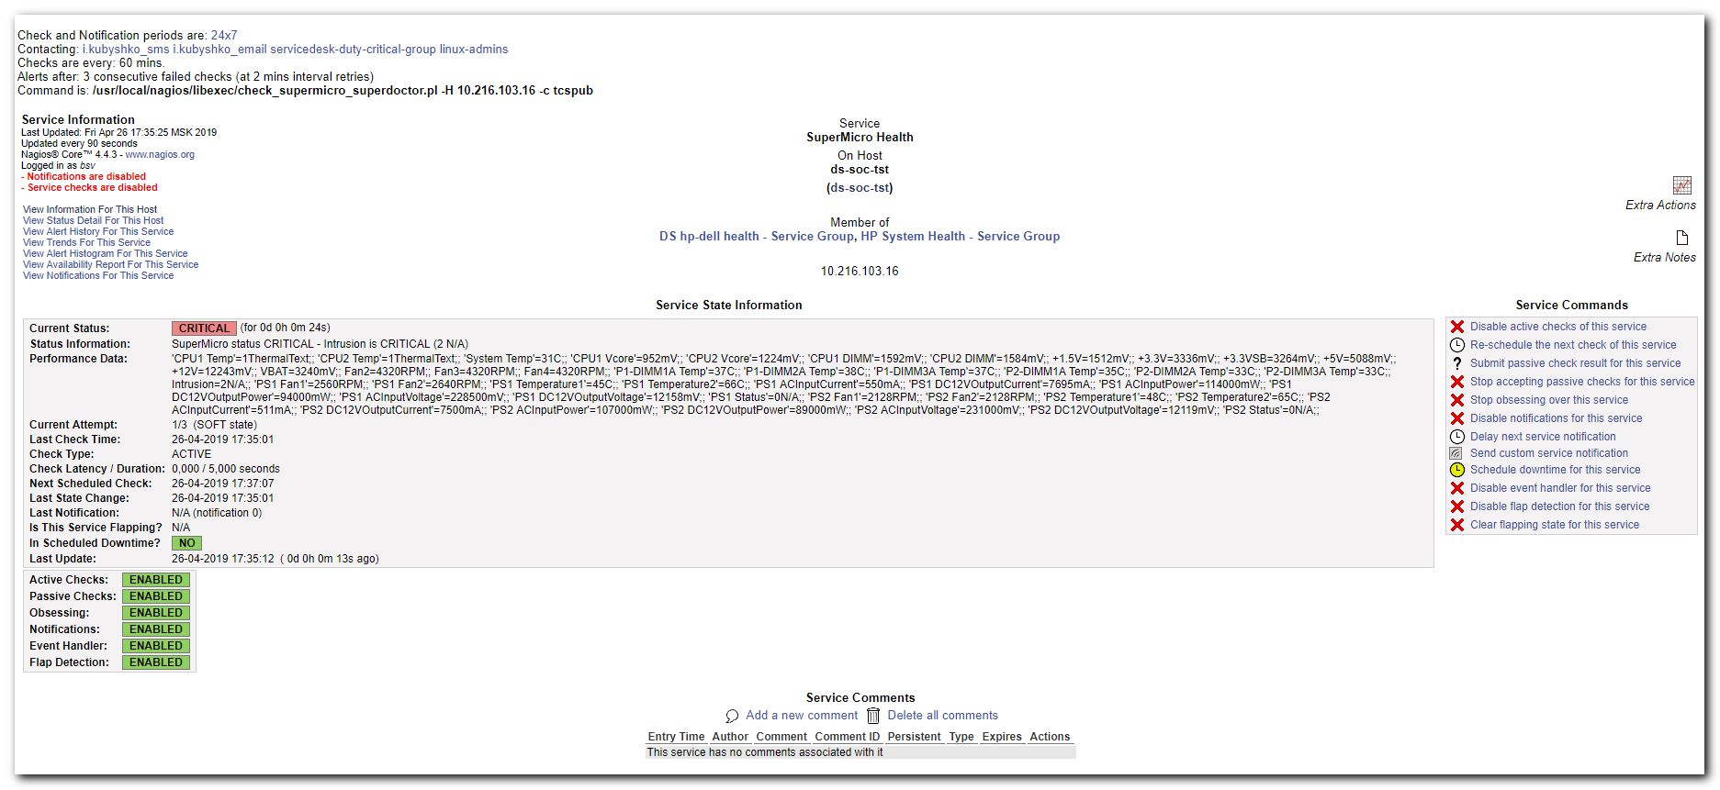

[root@vm-vol-nag4-tst objects]# snmpwalk -v 2c -c tcspub 10.216.103.16 1 | head
SNMPv2-MIB::sysDescr.0 = STRING: Linux ds-soc-tst.tcsbank.ru 3.10.0-862.el7.x86_64 #1 SMP Wed Mar 21 18:14:51 EDT 2018 x86_64
SNMPv2-MIB::sysObjectID.0 = OID: NET-SNMP-MIB::netSnmpAgentOIDs.10
DISMAN-EVENT-MIB::sysUpTimeInstance = Timeticks: (487242) 1:21:12.42
SNMPv2-MIB::sysContact.0 = STRING: Me <me@example.org>
SNMPv2-MIB::sysName.0 = STRING: ds-soc-tst.tcsbank.ru
SNMPv2-MIB::sysLocation.0 = STRING: Sitting on the Dock of the Bay
SNMPv2-MIB::sysServices.0 = INTEGER: 72
SNMPv2-MIB::sysORLastChange.0 = Timeticks: (4) 0:00:00.04
SNMPv2-MIB::sysORID.1 = OID: SNMP-MPD-MIB::snmpMPDCompliance
SNMPv2-MIB::sysORID.2 = OID: SNMP-USER-BASED-SM-MIB::usmMIBCompliance
[root@vm-vol-nag4-tst objects]#

SNMPv2-SMI::enterprises.10876.2.1.1.1.1.2.45 = STRING: "PS1 Status"
SNMPv2-SMI::enterprises.10876.2.1.1.1.1.2.56 = STRING: "PS2 Status"

[support@centos ~]$ ssh -oStrictHostKeyChecking=no -f -N -L 8444:localhost:8444 root@10.216.103.16
root@10.216.103.16's password:
[support@centos ~]$ ps aux | grep ssh
root 1130 0.0 0.0 82572 1272 ? Ss Apr11 0:00 /usr/sbin/sshd
support 2772 0.0 0.0 52968 580 ? Ss Apr11 0:02 /usr/bin/ssh-agent /bin/sh -c exec -l /bin/bash -c "/usr/bin/startkde"
support 5449 0.0 0.0 78380 1148 ? Ss 18:16 0:00 ssh -oStrictHostKeyChecking=no -f -N -L 8444:localhost:8444 root@10.216.103.16
support 5451 0.0 0.0 112652 964 pts/7 R+ 18:16 0:00 grep --color=auto ssh
[support@centos ~]$

#
# Username: ADMIN
# Password: ADMIN
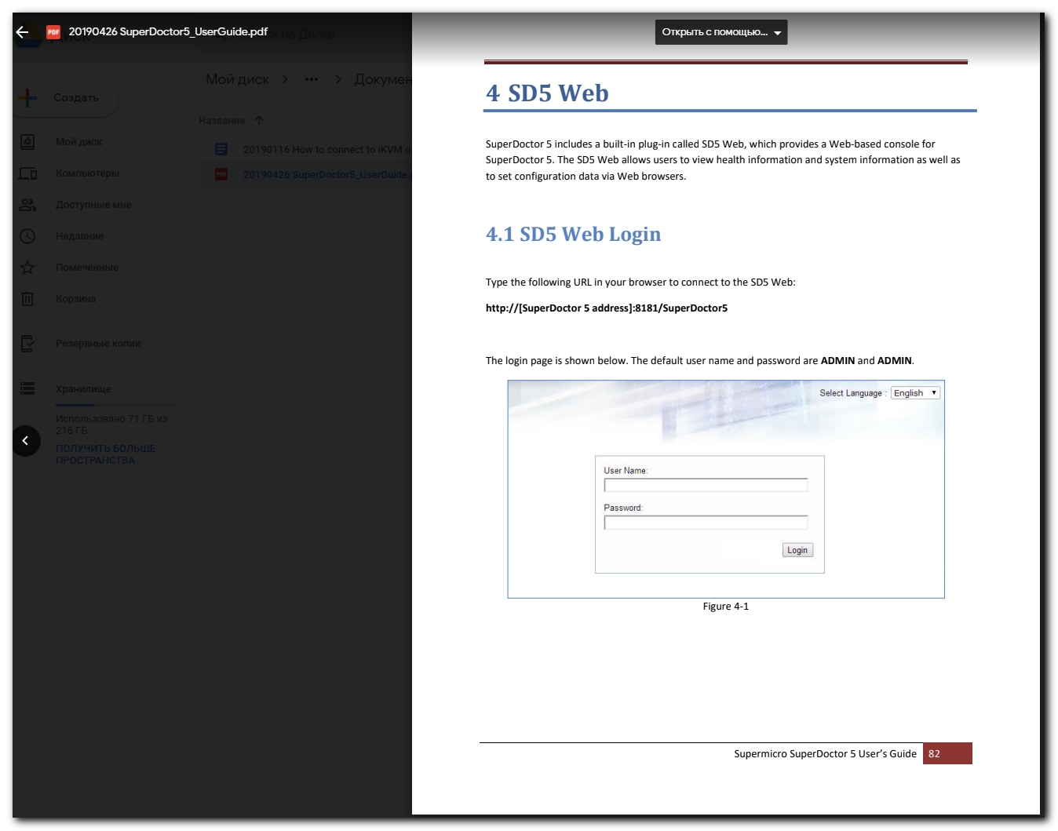

https://127.0.0.1:8444/SuperDoctor5/
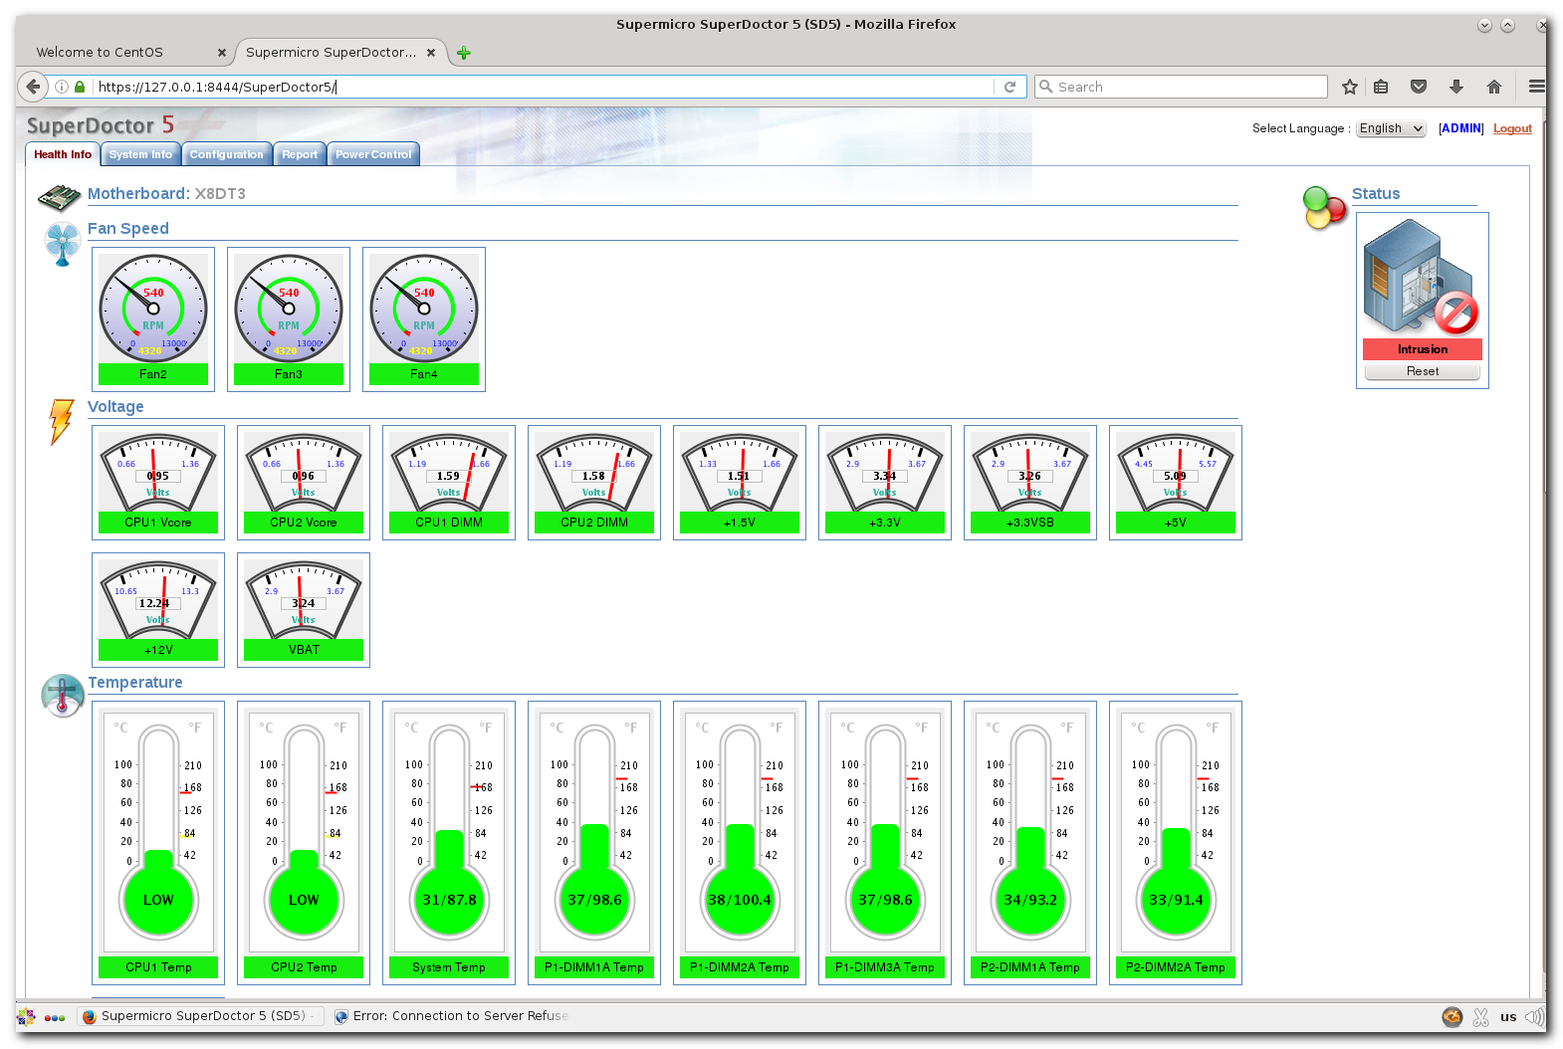
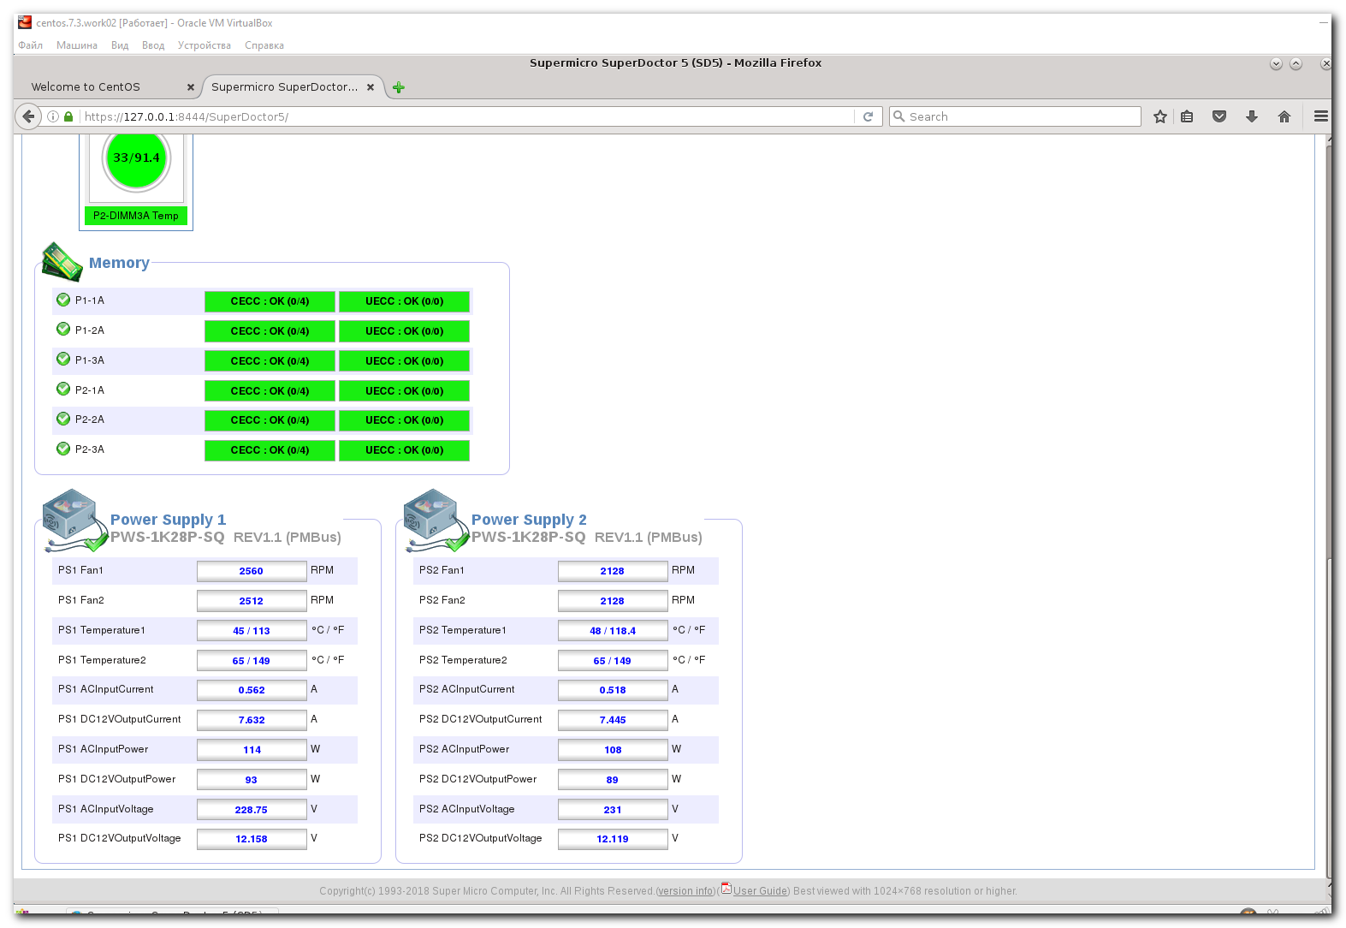
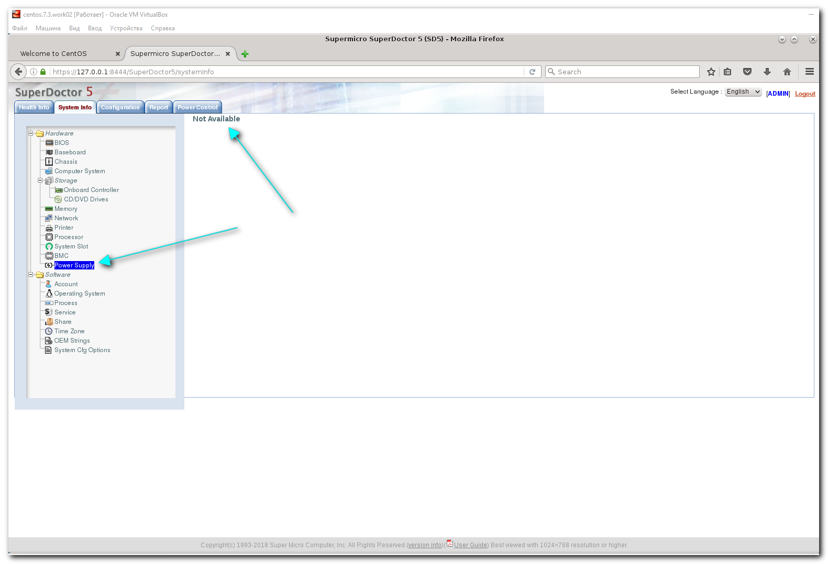

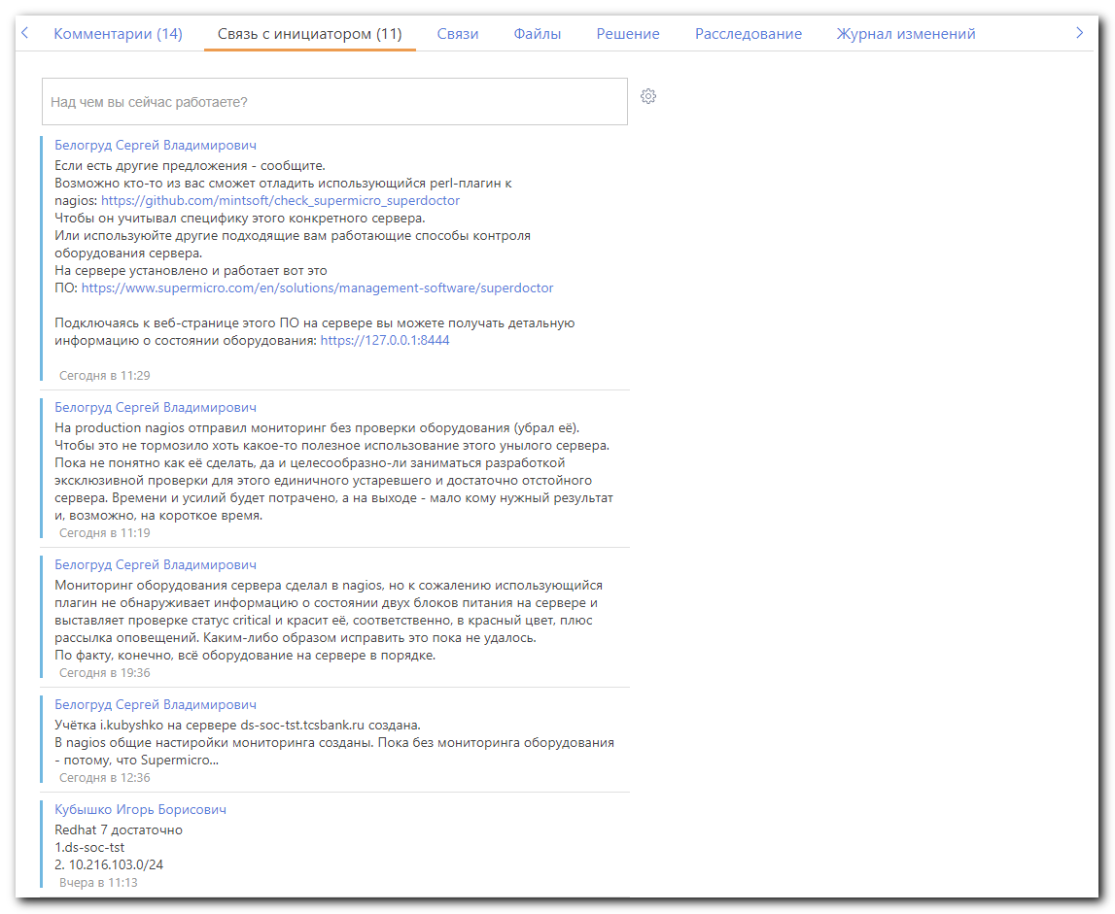

Белогруд Сергей Владимирович
Если есть другие предложения - сообщите.
Возможно кто-то из вас сможет отладить использующийся perl-плагин к nagios: https://github.com/mintsoft/check_supermicro_superdoctor
Чтобы он учитывал специфику этого конкретного сервера.
Или используюйте другие подходящие вам работающие способы контроля оборудования сервера.
На сервере установлено и работает вот это ПО: https://www.supermicro.com/en/solutions/management-software/superdoctor

Подключаясь к веб-странице этого ПО на сервере вы можете получать детальную информацию о состоянии оборудования: https://127.0.0.1:8444

Сегодня в 11:29
Белогруд Сергей Владимирович
На production nagios отправил мониторинг без проверки оборудования (убрал её).
Чтобы это не тормозило хоть какое-то полезное использование этого унылого сервера.
Пока не понятно как её сделать, да и целесообразно-ли заниматься разработкой эксклюзивной проверки для этого единичного устаревшего и достаточно отстойного сервера. Времени и усилий будет потрачено, а на выходе - мало кому нужный результат и, возможно, на короткое время.

Сегодня в 11:19
Белогруд Сергей Владимирович
Мониторинг оборудования сервера сделал в nagios, но к сожалению использующийся плагин не обнаруживает информацию о состоянии двух блоков питания на сервере и выставляет проверке статус critical и красит её, соответственно, в красный цвет, плюс рассылка оповещений. Каким-либо образом исправить это пока не удалось.
По факту, конечно, всё оборудование на сервере в порядке.

#
# 20190522
#

[s.belogrud@TCS4357]# ssh bsv@ds-soc-tst
Last login: Wed May 22 10:28:03 2019 from tcs4357.tcsbank.ru
[bsv@ds-soc-tst ~]$ sudo -i
[sudo] password for bsv:
[root@ds-soc-tst ~]#

[root@ds-soc-tst ~]# lsblk -o NAME,TYPE,MOUNTPOINT,FSTYPE,SIZE
NAME TYPE MOUNTPOINT FSTYPE SIZE
sda disk 9.1T
├─sda1 part 1M
├─sda2 part /boot xfs 1G
└─sda3 part LVM2_member 9.1T
├─rhel-root lvm / xfs 50G
├─rhel-swap lvm [SWAP] swap 11.8G
└─rhel-home lvm /opt xfs 9T
[root@ds-soc-tst ~]#

[root@ds-soc-tst ~]# ip -f inet addr | grep inet
inet 127.0.0.1/8 scope host lo
inet 10.216.103.16/24 brd 10.216.103.255 scope global noprefixroute enp4s0f1
[root@ds-soc-tst ~]#

[root@ds-soc-tst ~]# ip -f inet addr
1: lo: <LOOPBACK,UP,LOWER_UP> mtu 65536 qdisc noqueue state UNKNOWN group default qlen 1000
inet 127.0.0.1/8 scope host lo
valid_lft forever preferred_lft forever
5: enp4s0f1: <BROADCAST,MULTICAST,UP,LOWER_UP> mtu 1500 qdisc mq state UP group default qlen 1000
inet 10.216.103.16/24 brd 10.216.103.255 scope global noprefixroute enp4s0f1
valid_lft forever preferred_lft forever
[root@ds-soc-tst ~]#

[root@ds-soc-tst ~]# find /etc/sysconfig/network-scripts/ -name ifcfg-\* -exec echo \; -exec echo {} \; -exec cat {} \;

/etc/sysconfig/network-scripts/ifcfg-lo
DEVICE=lo
IPADDR=127.0.0.1
NETMASK=255.0.0.0
NETWORK=127.0.0.0
# If you're having problems with gated making 127.0.0.0/8 a martian,
# you can change this to something else (255.255.255.255, for example)
BROADCAST=127.255.255.255
ONBOOT=yes
NAME=loopback

/etc/sysconfig/network-scripts/ifcfg-enp7s0f1
TYPE=Ethernet
PROXY_METHOD=none
BROWSER_ONLY=no
BOOTPROTO=dhcp
DEFROUTE=yes
IPV4_FAILURE_FATAL=no
IPV6INIT=yes
IPV6_AUTOCONF=yes
IPV6_DEFROUTE=yes
IPV6_FAILURE_FATAL=no
IPV6_ADDR_GEN_MODE=stable-privacy
NAME=enp7s0f1
UUID=8ab5e7b9-8e78-4eed-8530-a3161a079ab5
DEVICE=enp7s0f1
ONBOOT=no

/etc/sysconfig/network-scripts/ifcfg-enp4s0f0
TYPE=Ethernet
PROXY_METHOD=none
BROWSER_ONLY=no
BOOTPROTO=dhcp
DEFROUTE=yes
IPV4_FAILURE_FATAL=no
IPV6INIT=yes
IPV6_AUTOCONF=yes
IPV6_DEFROUTE=yes
IPV6_FAILURE_FATAL=no
IPV6_ADDR_GEN_MODE=stable-privacy
NAME=enp4s0f0
UUID=15f7c7ed-d543-4a3a-8be8-08cb0e86b19b
DEVICE=enp4s0f0
ONBOOT=no

/etc/sysconfig/network-scripts/ifcfg-enp7s0f0
TYPE=Ethernet
PROXY_METHOD=none
BROWSER_ONLY=no
BOOTPROTO=dhcp
DEFROUTE=yes
IPV4_FAILURE_FATAL=no
IPV6INIT=yes
IPV6_AUTOCONF=yes
IPV6_DEFROUTE=yes
IPV6_FAILURE_FATAL=no
IPV6_ADDR_GEN_MODE=stable-privacy
NAME=enp7s0f0
UUID=a2c18d0e-0970-4b44-bf00-0246d67c9858
DEVICE=enp7s0f0
ONBOOT=no

/etc/sysconfig/network-scripts/ifcfg-enp4s0f1
NAME="enp4s0f1"
DEVICE="enp4s0f1"
ONBOOT=yes
NETBOOT=yes
UUID="8dc1f4ea-afc0-42bd-b752-e9b3d29b232c"
IPV6INIT=no
BOOTPROTO=none
TYPE=Ethernet
IPADDR=10.216.103.16
PREFIX=24
GATEWAY=10.216.103.254
DNS1=10.219.50.4
DNS2=10.219.50.5
DOMAIN=tcsbank.ru
[root@ds-soc-tst ~]#

